Emkan Finance



Migration Drop 1 , 2
Topup , Micro , Refinance , Direct PF and Advanced Salary
Mobile Flow (V 2.5)
September 15, 2024

Contents
Document Version History 4
Document Review & Approval History 4
Document References 4
1. Introduction 5
Document Purpose 5
Solution Objectives 6
Key Requirements: 6
Scope 7
Assumption 7
High Level Business Requirements 8
BRD References :- 8
Architecture Overview 9
Architecture Layers 9
• Diagram 9
GWs Integration 12
12
Core Systems 13
Logical Application Architecture 13
1-Transact Loan Management System (LMS) 13
2-Newgen iBPS LOS 14
3- MS-Dynamics 14
4- ENME 14
1- Emkan Payment System Hub (PSH) 16
2- Emkan Notification Engine 16
3- Emkan Rules Engine 16
6- Registration Microservice 16
Quality and rule engine 17
Parallel Run and Coexistence 18
Inquiries: 18
1-Aggregator Logic 18
2-Dispatcher Logic 19
• Description 19
Execution Flow View 21
.1. Configuration 21
1. Manage My Profile 24
2. Dashboard Flow S2 25
3. Loan Eligibility Flow (Lead Generation Flow ). S1 33
4. Customer declaration s2 38
5. Upload Document Flow S3 48
6. Quality Flow 49
7. Offering Flow 51
8. IVR Flow 54
9. BuyCommodity Flow 56
10. IBAN Verification Flow 59
11. ContractSigning Flow 66
12. Sanad Flow 67
13. view sale authorization Flow 69
14. Sell commodity Flow 69
15. Disbursment Flow 70
16. MissDocument Flow 70
Deployment and Security View 71
Appendix A - Architectural Decisions 72
72
Appendix D – Failing Retry Policy 72
Appendix E – Cooling Period 73
Appendix H – Retention Policy 73
Appendix R – Risks 73
Appendix I – General Impacts 74
Appendix T – Third Parties 74

Document Version History
Ver | Date | Author | Change Description
0.1 | 15/09/2024 | Mohammed Ishaq  Mohamed Hosni
04 | 14/10/2024 | Mohammed Ishaq  Mohammed Hosni | Updated Iban Verification flow and Contract Signing
05 |  | Mohammed Hosni | High level Design Diagram  IBAN Diagram
06 |  | Mohammed Ishaq | UPDATE Description
07 | 22/10/2024 | Mohammed Ishaq | Updated Payment Flow
08 | 24/10/2024 | Mohammed Ishaq | Updated Newgen Flows
Table 2 Document Version History

Document Review & Approval History
Version | Reviewer | Approver | Review Date | Approval Date
0.1
Table 3 Document Review & Approval History

Document References
Document Name | Document Link

Acronym Defintion

Acronym | Description
ARB | Al Rajhi Bank
API | Application Programming Interface
OTP | One Time Password
BAU | Business as Usual (already implemented / As is)
MS | Microservice
AML | Anti-Money Laundering
IVR | Interactive Voice Response
SAMA | Saudi Central Bank
SIMAH | Saudi Credit Bureau

System Roles
List of all related systems and their roles as per the solution
System | Role
Mobile App | Customer Interface
Emkan Services | Integration , Business and Mobile BE Services
Kastle | Loan Orignation Banking System(LOS) has following modules:  Product Catalog  LMS Loan management System
LOS | Loan Origination system (newgen)
Qarar | Decision Engine Service[third party], it implements a decision engine based on credit bureau data. it implements decision rules to accept, reject or refer card applications.
DMS | Document Management System
Unifonic | Third party for sending notification to customer like SMS or IVR
Emkan NE | Emkan Notification Engine for sending notification like IVR ,SMS, push notification
Emkan Rule Engine | System to apply rules provide set of rules result
Newgen | Loan Origination System
T24 | Loan Management System
Middleware | Integration Layer
CRM | Master Customer Data

Introduction
Emkan vision is to implement cutting-edge digital lending solutions that can power Emkan's next growth phase. This will be achieved through a phased migration of the existing loan portfolio and implementation of an integrated lending platform.
Key objectives are:
- Completely migrate customer records and loan accounts from Kastle to TRANSACT Core Banking.
- Implement a Newgen LOS to automate end-to-end digital lending workflows for all retail products.

Document Purpose
The purpose of this document is to produce a High-Level Design (HLD) and architecture for Retail Lending platform implementation and migration, the key building blocks of the solution and how those are going to address the key business and technology requirements. It will also provide the key architectural recommendations and architecture decisions discussed and agreed during the discovery workshops.

This document covers Direct PF and Advance Salary.

Solution Objectives
- Implement retail products using Newgen LOS and Transact LMS
- Migrate LMS loans accounts and contracts from Kastle to TRANSACT.
- Accelerate the decommissioning of the handicapped legacy core system, impacting time-to-market and stability.
- Mitigate the typical high-risk associated with this strategic initiative.
- Minimal impact on Emkan business and operation.
- Seamless transition through phased retail products data and functional migration.
- Readiness to host new products on the target platform as early as possible.
- Capitalize on Customer-Centricity through enterprise-wide Customer Master.
- Minimal or no impact on customer channels, B2B Gateways and external systems.
- Minimal integration impact on Emkan systems.
- Converge to Emkan new architecture and technology with superior qualities.

Key Requirements:
LMS Migration Requirements:
- Migrate customer, loan and product data from Kastle to TRANSACT
- Replicate functionalities for loan origination, management and collections
- Interfaces with accounting, reporting, downstream systems
- Role-based access controls and authorization protocols
- Performance, availability, reliability and scalability
- Audit trails and regulatory compliance for the solution

LOS Implementation Requirements:
- End-to-end digital workflows for loan applications
- Configurable approval hierarchies and conditions
- Customizable repayment and settlement options
- Real-time decision via underwriting and modeling
- Straight-through processing for majority of applications

Scope
-in scope
The scope of the document covers key architectural viewpoints including business architecture, solution architecture, logical application architecture, data architecture, and technology architecture. The document also captures all the business processes. The HLD provides the definition of the business processes, for Emkan’s Retail Products, solution architecture, logical application architecture, key technology services including integration services, data objects, deployment model. The Integration Team would provide the description of the interfaces proposed in septate IRD, the integration capabilities (messaging, connectivity, transformation, distribution, etc.) and the supporting integration formats (XML, JSON, EDI, Bus, File/FTP, DB, etc.).
I
- Build new retail technology platform (LMS & LOS).
- Configure the new LMS on TRANSACT and new LOS on Newgen to cater for the following existing business products:
- Retail Finance.
- Micro finance.
- Top-up.
- Refinance.
- Buyout.
- Auto-lease.
- Advanced Salary.
- Direct PF.
- Credit Card (LOS only).

-out of scope
- Kastle journey out of scope and required changes will covered in separate Document

Assumption
- Emkan Registration flow /Login Flow [BAU]
- Emkan Notification Engine [BAU]

High Level Business Requirements

ID | JIRA Ref. | Statement of Requirement
Migration Drop 1(LOS) |  |  | https://jira.emkanfinance.com.sa/browse/
Mobile Revamp |  |  | https://jira.emkanfinance.com.sa/browse/DF-9990
Migration Drop 2(LOS) |  |  | https://jira.emkanfinance.com.sa/browse/EDF-30
Migration Drop 2(LMS) |  |  | https://jira.emkanfinance.com.sa/browse/EDF-1572

BRD References :-

The following are the key strategic objectives of the Emkan Fintech Platform, as below:
- A fully- digital Loan Origination and Loan Management service platform that provides services throughout the value chain (loan origination to the disbursement and management)
- A digital platform that offers seamless connectivity with both internal and external systems and is created in accordance with financial industry best practices and standards as per Saudi laws and Emkan’s business model
- An internal loan underwriting capacity and approval/rejection capacity, that is fully automated and highly optimized, with improved support for Analytics based on rules engine for decision making as per B2B inputs
- Highly configurable workflows to serve the needs of different Loan products, offered by Emkan Finance
- Enabling end to end security to ensure the privacy and confidentiality of the customer’s data and Real-time customer data with CRM
- Customer onboarding- Customer registration or login
- Loan application- Customer selects a particular Loan product start application from Emkan channel.
- Loan eligibility and Contract sign- Customer due diligence, and eligibility based on Credit reports, income and monthly liabilities, with contract sign customer.
- Disbursement and Loan Management- Payment to customer and account and manage the further updates on monthly payments by customer, till last payment and contract closure in addition to loan early repayment, pas due management, loan amendment.
- Collection- Update collection management system, for regular or defaulted payments daily.

Drops :
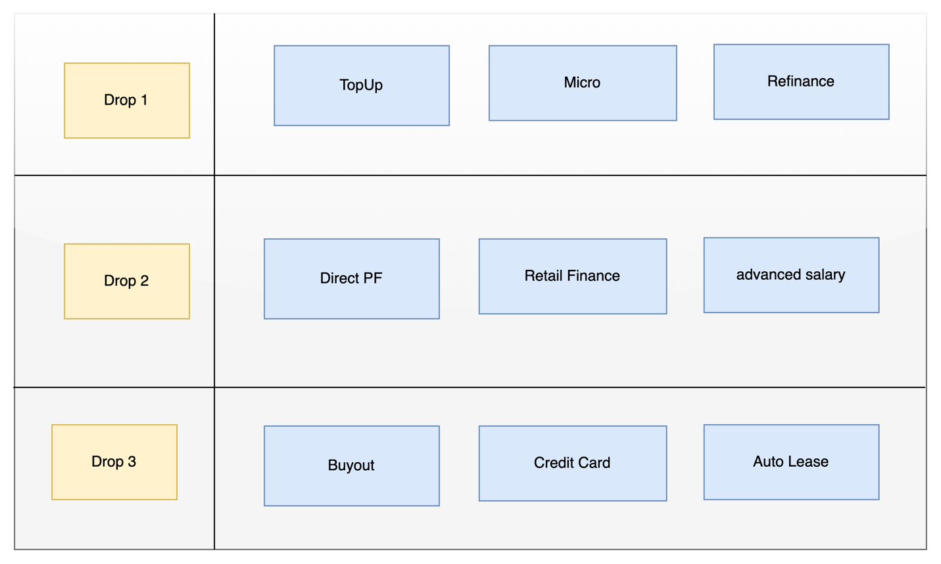

Architecture Overview

Our architecture will be Mix of the following:
- Cloud based Architecture using OCI
- Microservice Architecture
- Service Oriented Architecture
- Event Driven Architecture

Architecture Layers
- Channel
- External Gateway
- User Repository and Identity Management
- Back-end For Front-end (BFF)
- Integration Layer and internal API Gateway
- Core Systems
- Data Layer

Diagram
The below diagram will show how the architecture will be
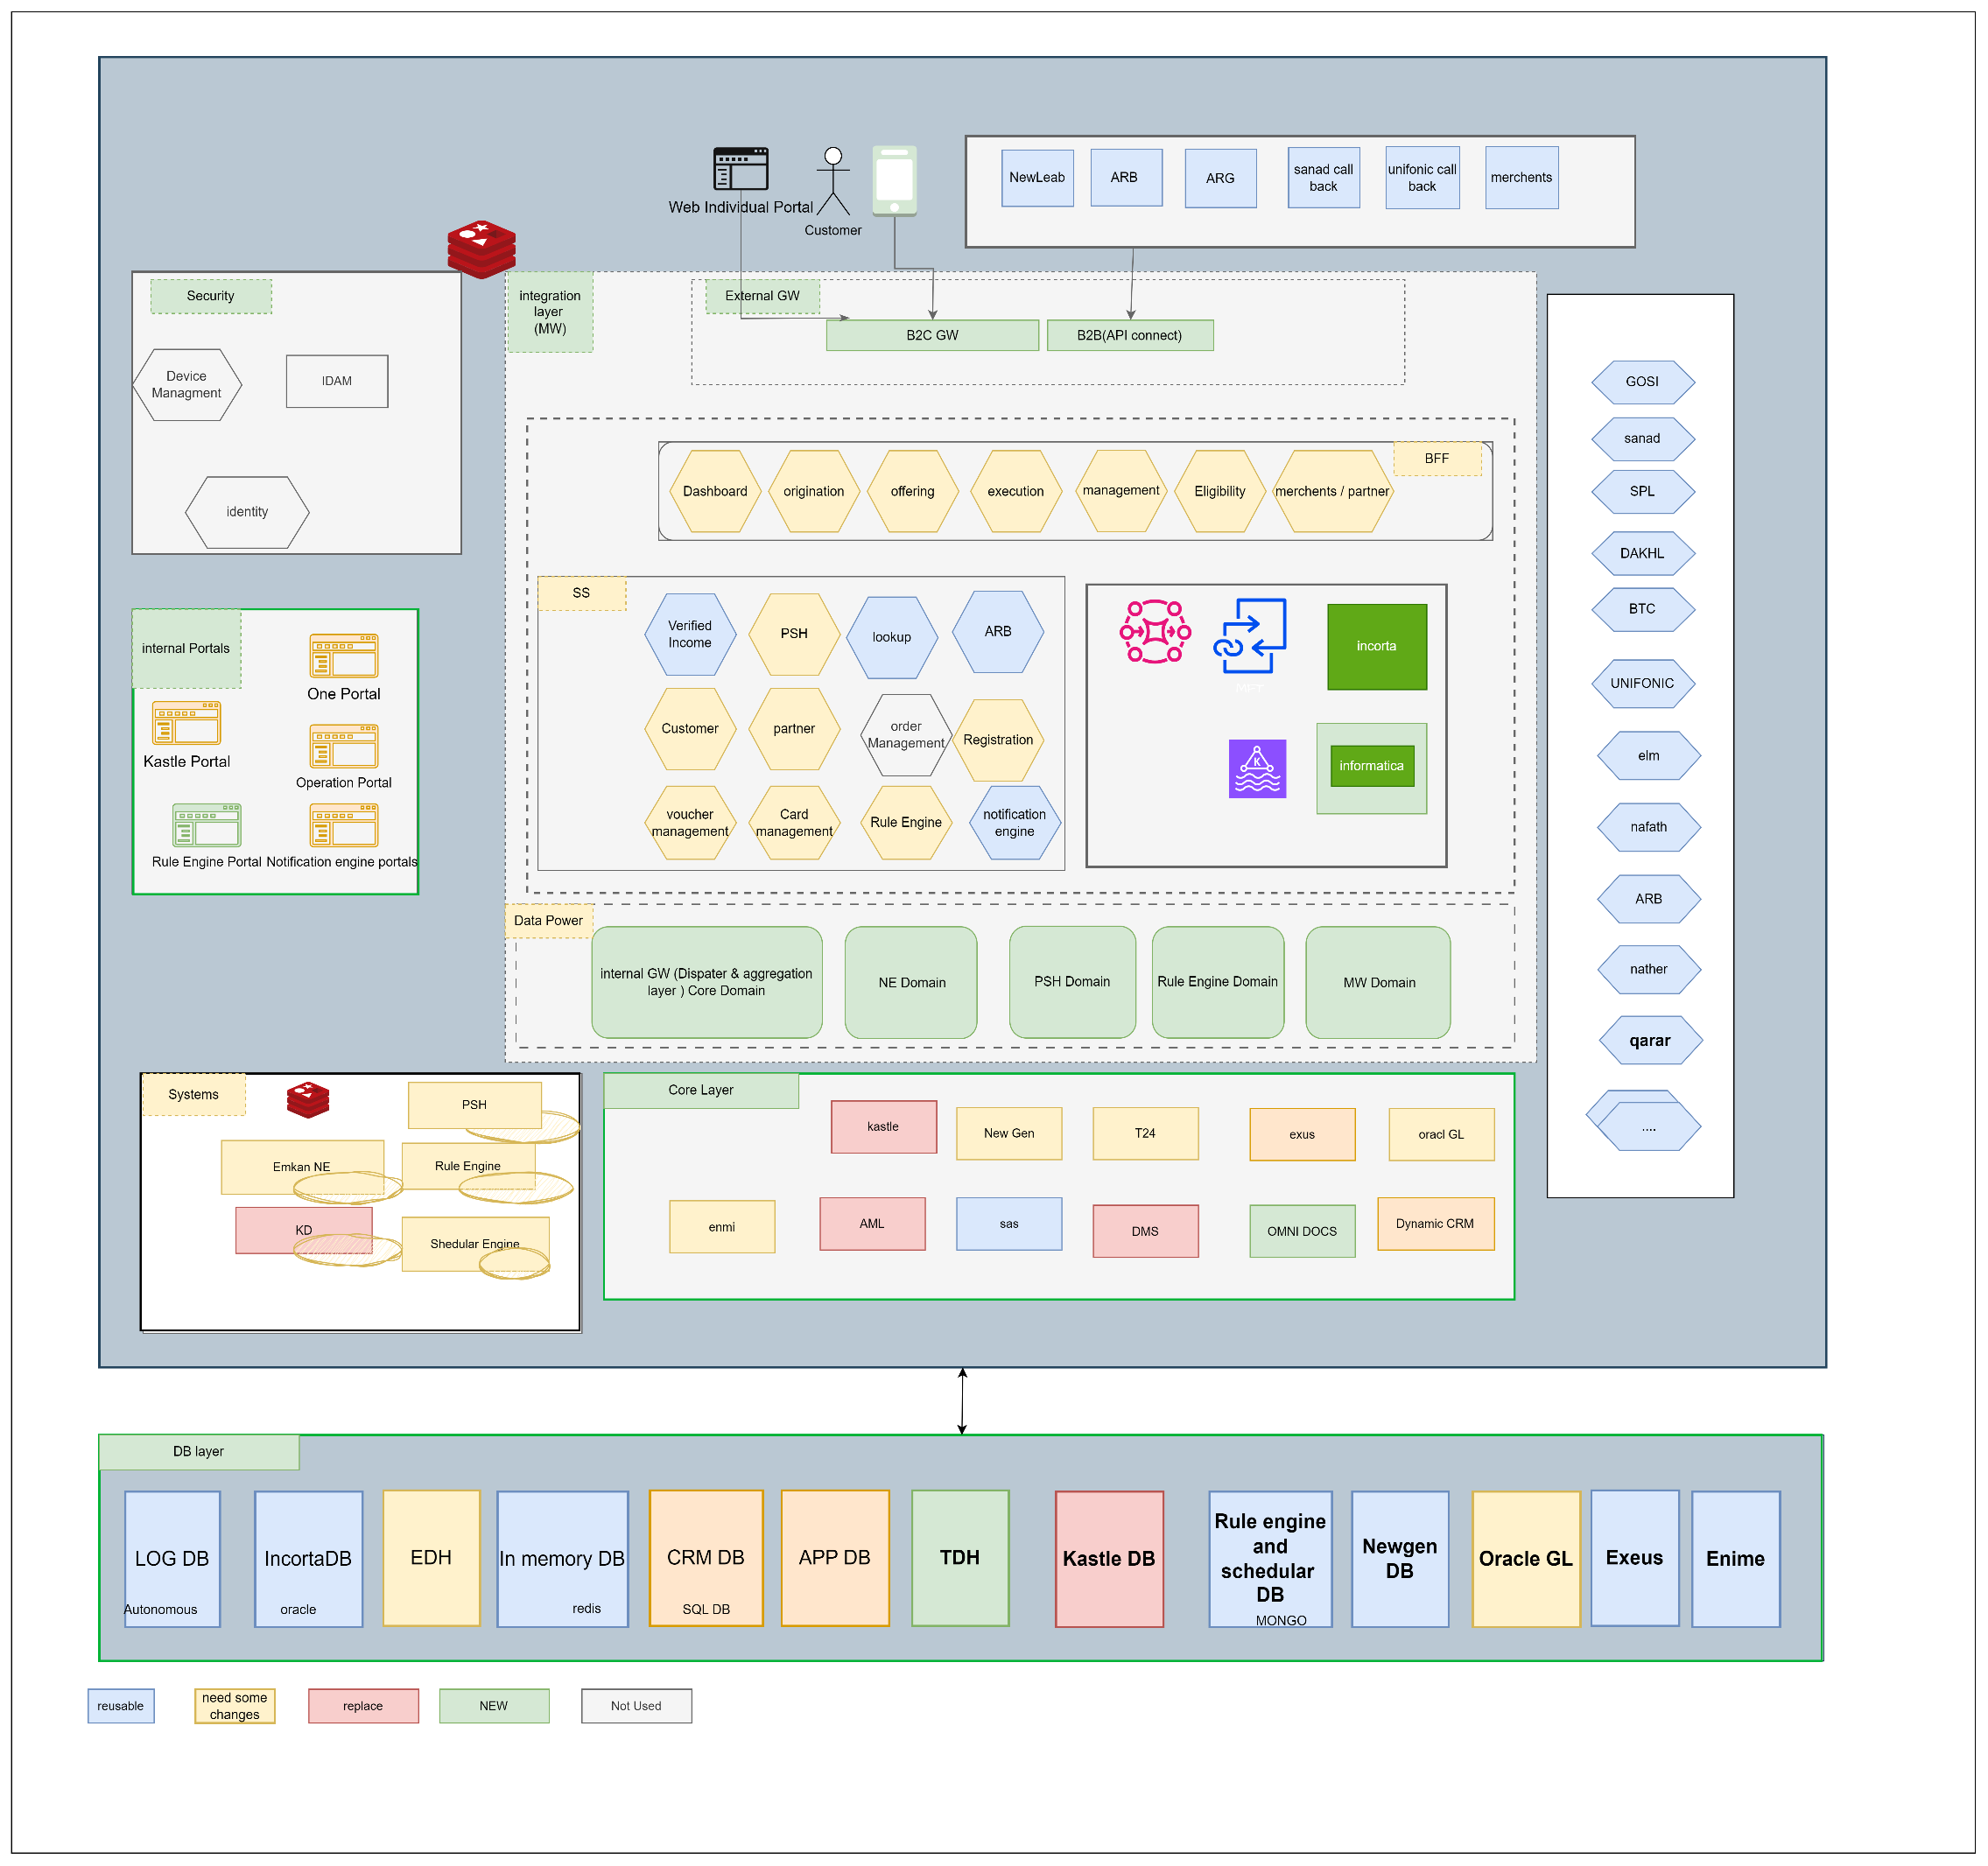

 | Name | Description
Channels
1 | Mobile Applications | Emkan Mobile Application
2 | Emkan’s web site | Emkan Mobile Application (Retail Finance RF)
3 | Kastle Back office | Branch journey and underwriting tasks
4 | Newgen Back office | and underwriting tasks
5 | Transact Back Office | LMS back-office tasks
6 | One Portal | Emkan one portal Staff portal
7 | Emkan’s Merchants Portal | Emkan merchant portal
8 | Merchant’s E-commerce Platforms | Like Apple or Jarir
9 | Emkan Branch | Newgen Branch journey
Internal Systems and Core Backends
1 | Temenos Transact | LMS Core Banking
2 | iBPS | Newgen LOS
3 | Kastle ULS | Kastle unified loan system
4 | MS Dynamics | CRM
5 | Oracle GL | GL
6 | Oracle MFT | Secured file transfer
7 | ENME | Sanction
8 | SAS | Provisioning
9 | Exus | Collection
LOS External 3rd Parties
1 | GOSI | None government employee income details
2 | Dakhli | government employee income details
3 | Saudi Post SPL | All the National address record of the customer
4 | Qarar | Qarar is credit decision and limit engine fetch and evaluates the customer credit report from SIMH and provides the scoring, rating, rule-based pricing and decision (accept, reject or refer)
5 | Unifonic | sending notification (SMS, IVR)
6 | Emdha | Digital Signature service
7 | DDCAP | This service is to be triggered for purchase/sale of commodity as per Sharia Law
8 | Sanad-Nafith | Promissory Note- Nafith Platform, approves and certifies the promissory note and as the final step the promissory note is saved for future reference
9 | Nafath | National single sign on and Absher details
10 | Elm | sending OTP /getting Absher details, verify mobile ownership
11 | ARB-Channel | Al-Rajhi Bank provides the information for if the customer is an ARB customer and its Account information, IBAN verification
12 | Saudi Payment | IBAN verification for none ARB customers
LMS External 3rd Parties
1 | Neolep PGW | Customer payment
2 | ARB-Mokafaa | ARB Loyalty program
3 | SIMAH | SIMAH file as part of compliance
4 | Natheer | Natheer watch list
5 | ARB-DD | ARB direct deduction file
6 | Nafith | Cancel promissory note
7 | MOJ Najez | Capture Court Case ID

GWs Integration
The integration layer offers other tools and systems for integration
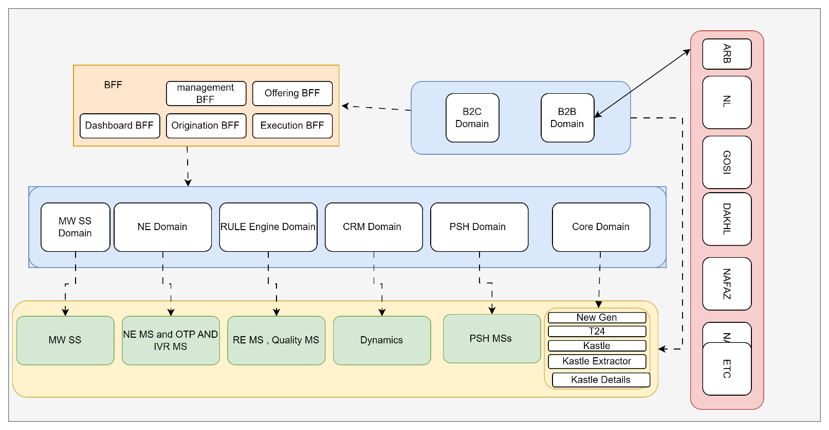

Core Systems

Figure 1 Core Backends

Core Backends
1 | Temenos Transact | LMS
2 | Newgen iBPs | LOS
3 | Kastle | ULS
4 | MS Dynamics | CRM
5 | Oracle GL | GL
6 | ENME | Sanction
7 | Exus | Collection
8 | Emkan Payment System Hub PSH | Payment MS
9 | Emkan Notification Engine | Notification engine
10 | Emkan Rules Engine | Rule engine
11 | SAS | Provisioning

Logical Application Architecture

Figure 2 LOS,LMS,CRM AND ENME LOGICAL ARCHTECTURE

1-Transact Loan Management System (LMS)

System | Transact | Vendor Name |  | Temenos
Description | Core Banking system by Temenos used to manage LMS
Infrastructure | OCI | Deployment | Containerization
Container Orchestrator | OpenShift | Release | R22
System Components
Transact Core | LMS Core Banking | Temenos Data Hub | Analytics and reporting platform
Transact Backoffice | Transact user interface for operation team | Data Event Streaming DES | Event streaming component capturing real-time transactions
IRIS Framework | API Framework

2-Newgen iBPS LOS

System | Transact | Vendor Name |  | Temenos
Description | Core Banking system by newgen used to manage LOS
Infrastructure | OCI | Deployment | Virtual machines
Container Orchestrator | N/A | Release | xxx
System Components
iBPS | Process engine and application server | BRMS | rule engine (will be used for retail products )
OmniDocs | DMS

3- MS-Dynamics

System | MS Dynamics | Vendor Name |  | Microsoft
Description | CRM System
Infrastructure | OCI | Deployment | Virtual machines
Container Orchestrator | N/A | Release | xxx
System Components
Front-End | Web based front-end for operation and administration teams | Back-end App | Core CRM Logic
Integration services | API layer

4- ENME

System | ENME | Vendor Name |  | EJADA
Description | Sanction, screening and Customer Rating
Infrastructure | OCI | Deployment | Virtual machines
Container Orchestrator | N/A | Release | xxx
System Components
ENME Front-end | Web based front-end for operation and administration teams | Screening engine | Sanction and screening engine

1- Emkan Payment System Hub (PSH)

System | Emkan Payment System Hub | Vendor Name |  | Emkan
Description | Payment system receive online payment from different sources and reflect it to core systems
Infrastructure | OCI | Deployment | Containerization
Container Orchestrator | Kubernetes | Release | N/A
System Components
Transact Dispatcher | Reflects payment to Transact | Kastle Dispatcher | Reflects payment to Kastle
Cortex Dispatcher | Reflects payment to cortex

2- Emkan Notification Engine

System | Emkan Notification Engine | Vendor Name |  | Emkan
Description | Handle multiple type of notifications sent across the system
Infrastructure | OCI | Deployment | Containerization
Container Orchestrator | Kubernetes | Release | N/A

3- Emkan Rules Engine

System | Emkan Rules Engine | Vendor Name |  | Emkan
Description | Rules engine offer friendly user interface used by Emkan Business Team to define different product eligibility rules
Infrastructure | OCI | Deployment | Containerization
Container Orchestrator | Kubernetes | Release | N/A

6- Registration Microservice

System | Emkan Rules Engine | Vendor Name |  | Emkan
Description | Handle customer onboarding and integrate with SPL
Infrastructure | OCI | Deployment | Containerization
Container Orchestrator | Kubernetes | Release | N/A

Quality and rule engine
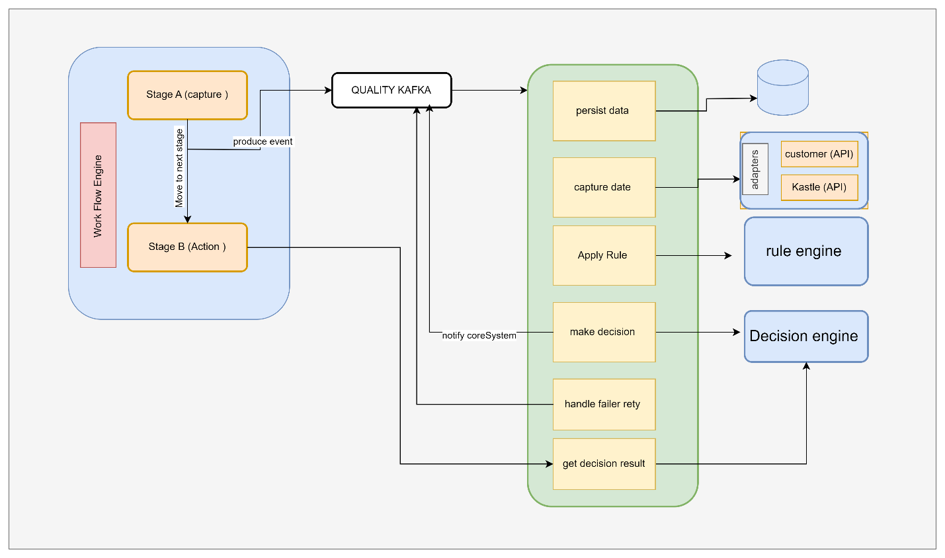

Parallel Run and Coexistence

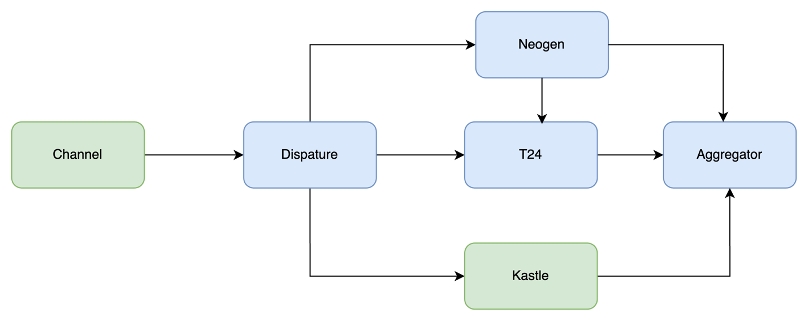
The migration project will be carried out as a series of drops each of them will have a group of Emkan’s Retail products. Business availability and continuity is a must.
During the project Emkan’s Retail Products Portfolio will be as the following:
  - Products not migrated and it will be availed through the Kastle stack
  - Products migrated availed through the Newgen, Transact stack.
  - Applications started and not completed before their products moved to the new technology stack at cutoff time will continue old stack until Loan contracts are created and will be migrated to new stack as delta migration

Inquiries:
- none migrated Products Inquires will be executed and fetched from old stack.
- migrated Products Inquires will be executed and fetched from new stack.
To achieve these requirements two components would be implemented inside IBM integration layer

1-Aggregator Logic
Integration layer will handle the coexistence aggregation logic by consuming Kastle (LOS& LMS) endpoints and Transact and Newgen endpoints related to
- Dashboard (to retrieve active contracts and ongoing applications from different systems )
- Active and ongoing application on both system

For more details you can refer to execution flow

2-Dispatcher Logic
Mobile will call new APIs exposed on B2C GW and will reach to new stack

Description
Layer | Service/component | Role
Channels | Staff | One Portal, Core Systems
 | Customer | Emkan Mobile App, Website
 | Partners | Merchant Portal, Merchant E-Commerce Platform
Gateway | B2C  IBM DataPower | Receiving traffic from Channel Customer
Gateway | B2B | Receiving traffic from Channel Partners
Gateway | IG | Receiving traffic from BFF and Middleware Integration Microservice layer
Gateway | Dashboard | MS for doing transformation , aggregation,segregation ,... related to application dashboard communications like fetching all applications within stattistics from different core banking system,...
Security | IDAM(WSO2) | Identity Server for identity and access management,
Security | Identity Service | MS for identifying user [authentication/authorization]
Security | Device Management | MS for managing registered device of customer
Support Services | Emkan NE | Notification Engine for sending notification like SMS,IVR, push Notification Message and feeback caller
Support Services | Emkan Scheduler Engine | Scheduler Engine to Handling Job Tasks for Emkan
Support Services | Emkan Rule Engine | Rule Engine to apply Ruel Sets

Execution Flow View

Configuration
    - New Gen Configuration:
- Configure below stage for all products

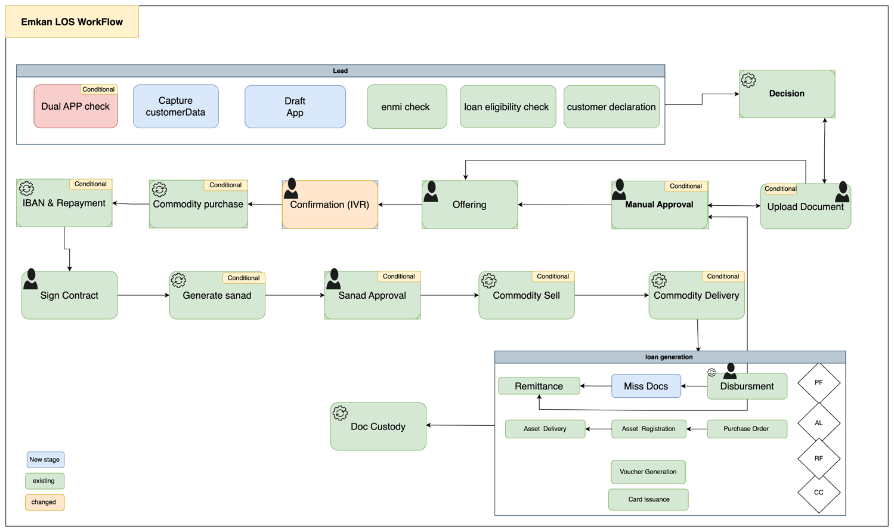

Description:

 | Task Name | Description
APP GENERATION |  | - Validate if application already exists.  - Capture customer personal information for creating an application.  - Create Draft application.  - Perform customer sanction and screening through ENMIE.  - Apply loan eligibility rules  - Capture customer information like Income,Expenses,total obligations as part of Customer Declaration.
Decision |  | Final decision and final offer if accepted.  If any document missing return required documents as part of Qarar response.
Upload Documents |  | Upload required documents.
Manual Approval |  | Move application to underwrite (L1-L9 ) for manual check
Miss Document |  | Ask customer to upload missed Document
Customer Offering Approval |  | Customer decides accept or reject final offer
Confirmation stage [IVR] |  | Triggering IVR call for loan confirmation
Commodity purchase maker |  | Purchasing commodity
Sign contract |  | Customer accept /reject Sign contract of all applications
Generate Sanad |  | System generates PN for customer
Sanad Approval |  | Customer decides accept or reject Sanad
Commodity sell maker |  | Selling commodity
Disbursement |  | Disbursement Stage
Remittance |  | Remittance Stage
Document custody |  | Complete of process

Configure Emkan Employee Users across all Emkan Functions which use Newgen Interface
    - DMS
- Product Required Documents
  - Salary Certificate
  - ID Certificate
- Application Required Documents
  - Contract summary
  - Certificate of ownership
  - Digital selling contract

    - T24
- Configure Accounting Finance cycle
    - Oracle GL
- Configure Accounting Finance cycle

    - Qarar
- AS IS except
    - Disable Direct PF
    - If customer applying for TopUp or Micro Qarar should not offer DirectPF
    - Refinance will be applicable for topup and micro products only
    - Qarar to return required/missing documents.

    - Kastle
- Freeze DirectPF application

    - Robotics
- Configure RPT to use new screens on Newgen Portal

Manage My Profile

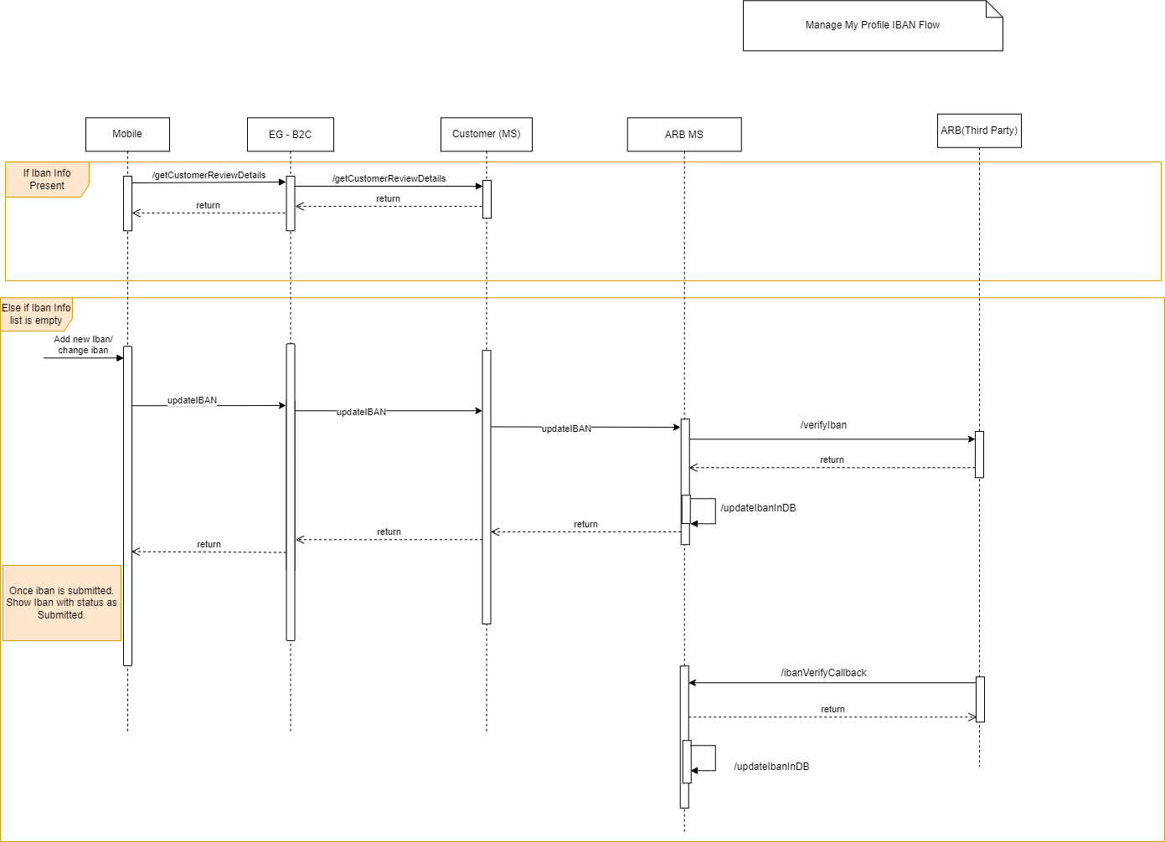

Description
System Provider | Action | Request | Response | Type | Description
Loan-Execution | getCustomerReviewDetails | AsIs | AsIs | Rest/Json | 1) Make sure IbanInformation is fetched from iban_verification table with attributes  i)isVerifiedFlag  ii) status  iii) isPrimary  iv) ibanInfo  2) If iban list is empty then allow user to enter iban and follow the update iban flow. Mark PrimaryIban with Y  3) If iban list is returned with isVerified flag as False then display iban with status as Submitted.
ARB | /updateIban | AsIs | AsIs | Rest/Json
ARB | /ibanVerifyCallback | AsIs | AsIs | Rest/Json

Dashboard Flow S2
- Diagram

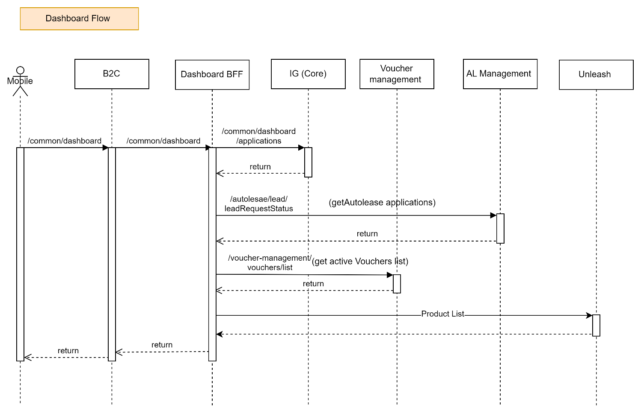

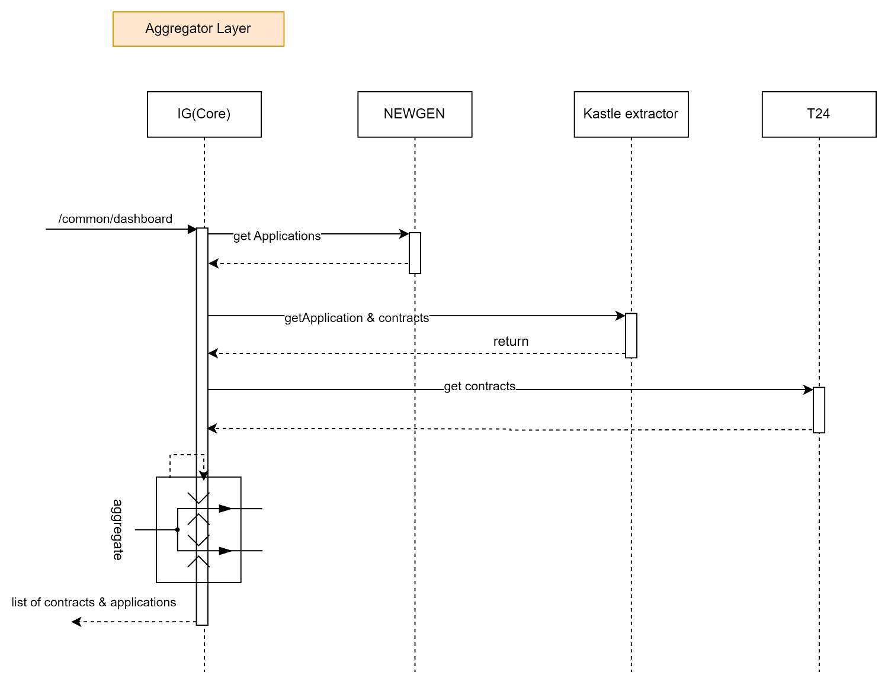

Newgen Flow (BRMS Check):
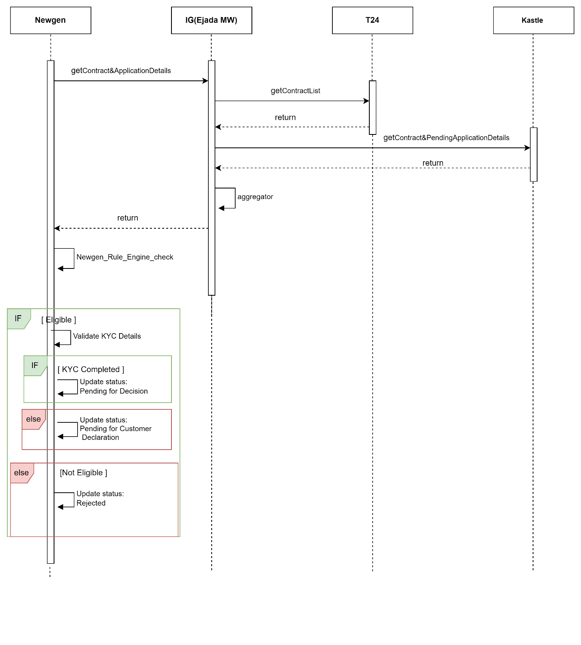
Dashboard Update ( Newgen)
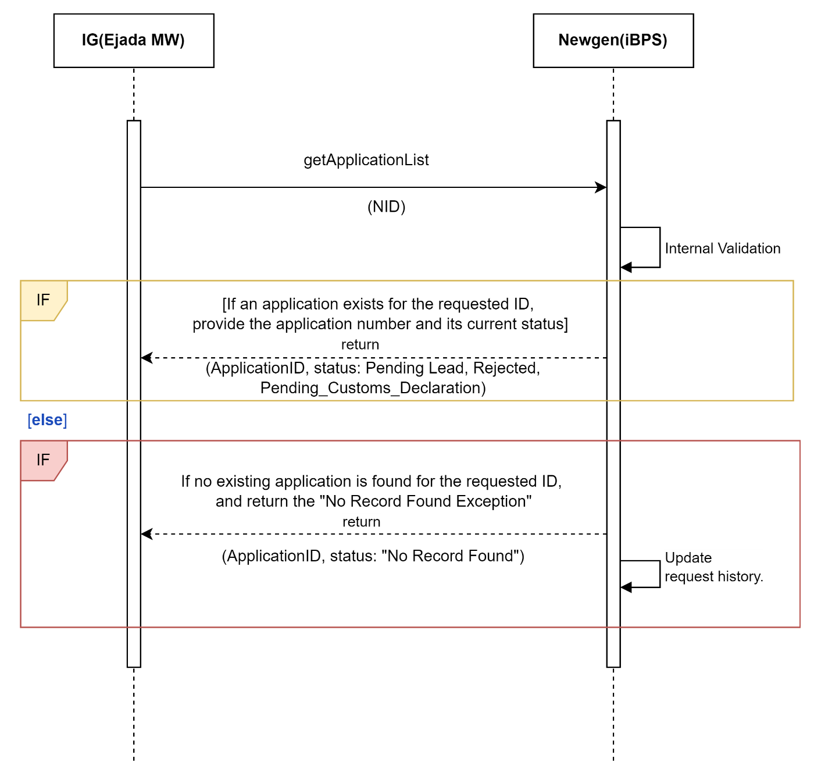

Description:

System Provider | Action | Request | Response | Type | Description
Dashboard | /common/dashboard | {  "status": "active",  "nationalId": "NID123456789"  } | {  "id": 123456,  "applicationId": "APP001",  "lastInstallmentDate": "2024-07-15",  "subProduct": "SubProduct A",  "product": "Product A",  "installmentAmount": 500.00,  "stage": "In Progress",  "totalFinancedAmount": 10000.00,  "amountRemaining": 3000.00,  "nextInstallmentDue": "2024-08-15",  "loannumber": "LN123456789",  "status": "active",  "substage": "Underwriting",  "subsourcingChannel": "Online",  "bp": "BP123",  "source": "Web",  "installmentRemainDuration": 5,  "remainingInstallmentNumber": "5",  "reasonCode": "RC001",  "reasonMessage": "Payment overdue",  "reasons": [  {  "reasonCode": "RC001",  "reasonmsg": "Payment overdue"  },  {  "reasonCode": "RC002",  "reasonmsg": "Insufficient funds"  }  ]  } |  | Instead of calling Kastle-Extractor call Integration Layer(Internal Data power) end point which will aggregate response from T24/Kastle/Newgen and send all applications.
Autolease | /leadRequestStatus | nationalId  phoneNumber | nationalId  dealerOffers  {  leadId,  leadStatus  }  autoleaseApplications{  } | REST/JSON
Voucher-Management | /vocucherList | nationalId | voucherId  amount  redeemedAmount  currency  merchantCode  applicationId  customerId  state  lastStateChange  piryDate  transactionId  voucherCode  createdAt  categoryCode  voucherIssuerName | REST/JSON

AppBanner Dashboard Flow:

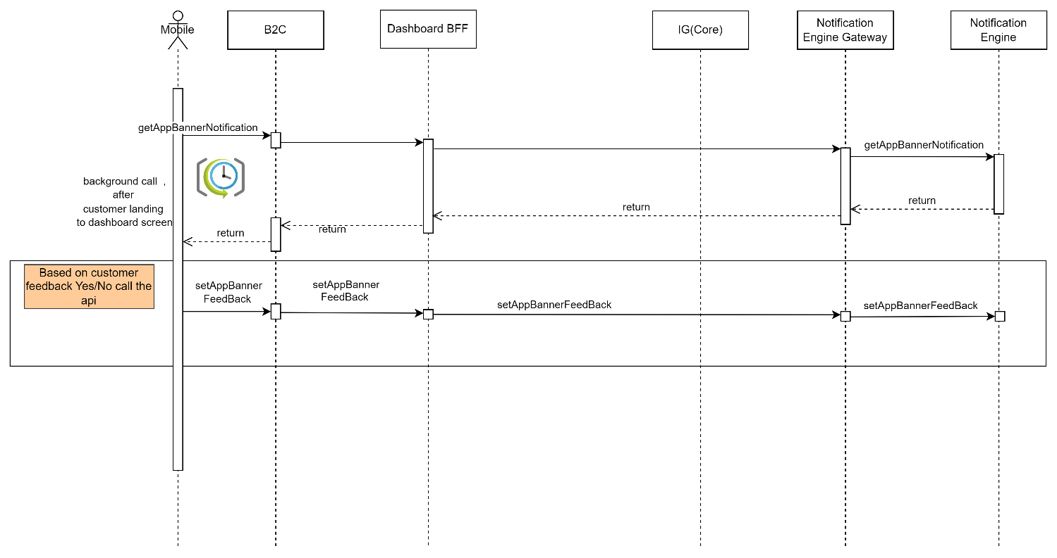

System Provider | Action | Request | Response | Type | Description
Dashboard | /common/dashboard | {  "status": "active",  "nationalId": "NID123456789"  } | {  "id": 123456,  "applicationId": "APP001",  "lastInstallmentDate": "2024-07-15",  "subProduct": "SubProduct A",  "product": "Product A",  "installmentAmount": 500.00,  "stage": "In Progress",  "totalFinancedAmount": 10000.00,  "amountRemaining": 3000.00,  "nextInstallmentDue": "2024-08-15",  "loannumber": "LN123456789",  "status": "active",  "substage": "Underwriting",  "subsourcingChannel": "Online",  "bp": "BP123",  "source": "Web",  "installmentRemainDuration": 5,  "remainingInstallmentNumber": "5",  "reasonCode": "RC001",  "reasonMessage": "Payment overdue",  "reasons": [  {  "reasonCode": "RC001",  "reasonmsg": "Payment overdue"  },  {  "reasonCode": "RC002",  "reasonmsg": "Insufficient funds"  }  ]  } |  | Instead of calling Kastle-Extractor call Integration Layer(Internal Data power) end point which will aggregate response from T24/Kastle/Newgen and send all applications.
Dashboard BFF | getAppBannerNotification | AsIs | AsIs |  | Response should contain  eventCode,feedback,notificationStage,message,action,title,nid.
Dashboard BFF | setAppBannerFeedBack | AsIs | AsIs

Loan Eligibility Flow (Lead Generation Flow ). S1
- Diagram

TopUp , Micro , Direct PF and Advanced Salary

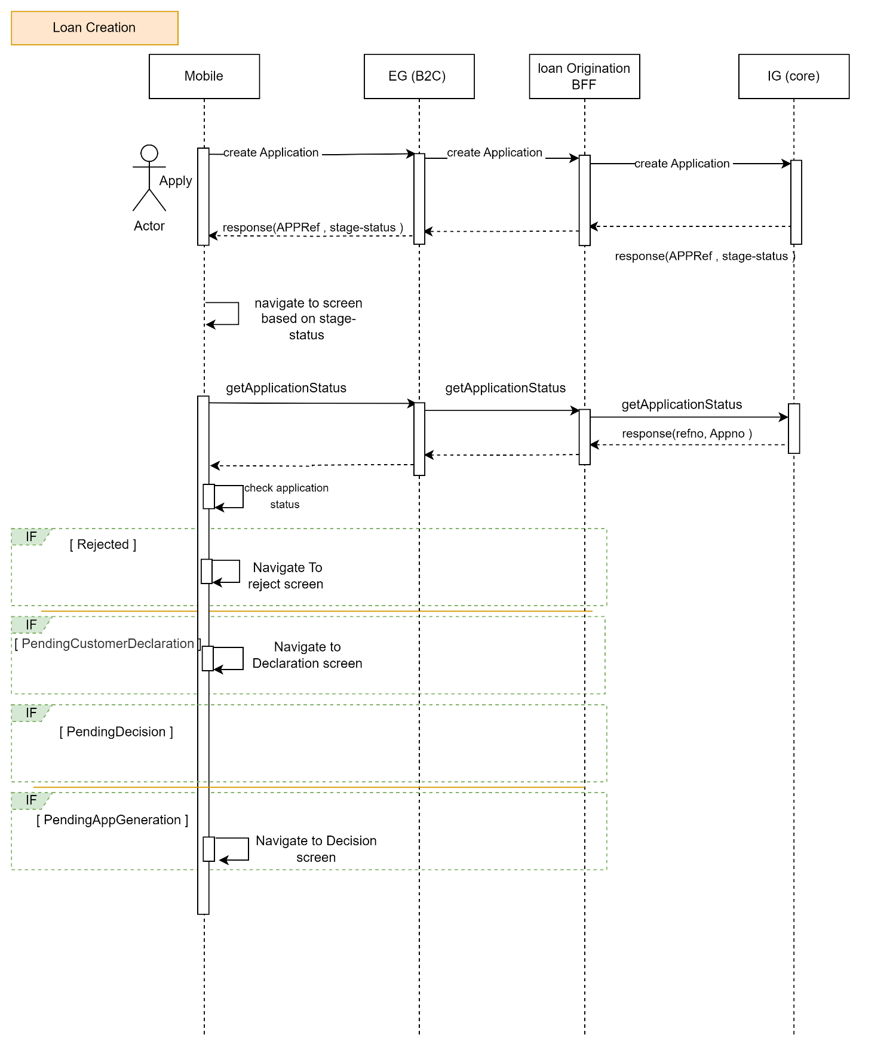

REFINANCE
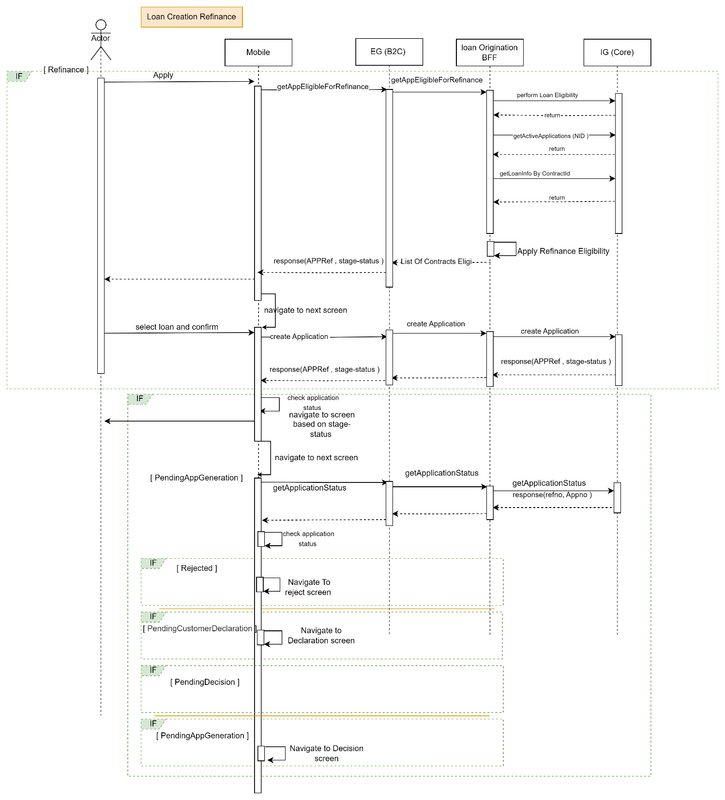

NewGen Flow (Create Application):

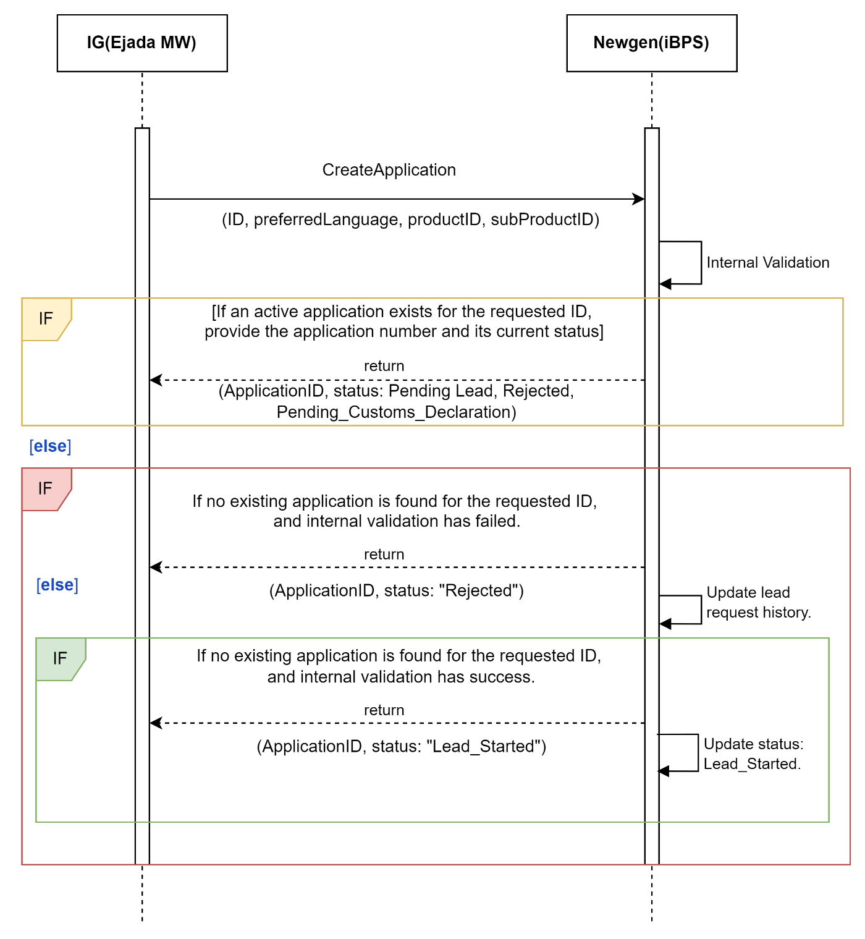

ENME Check ( NewGen)

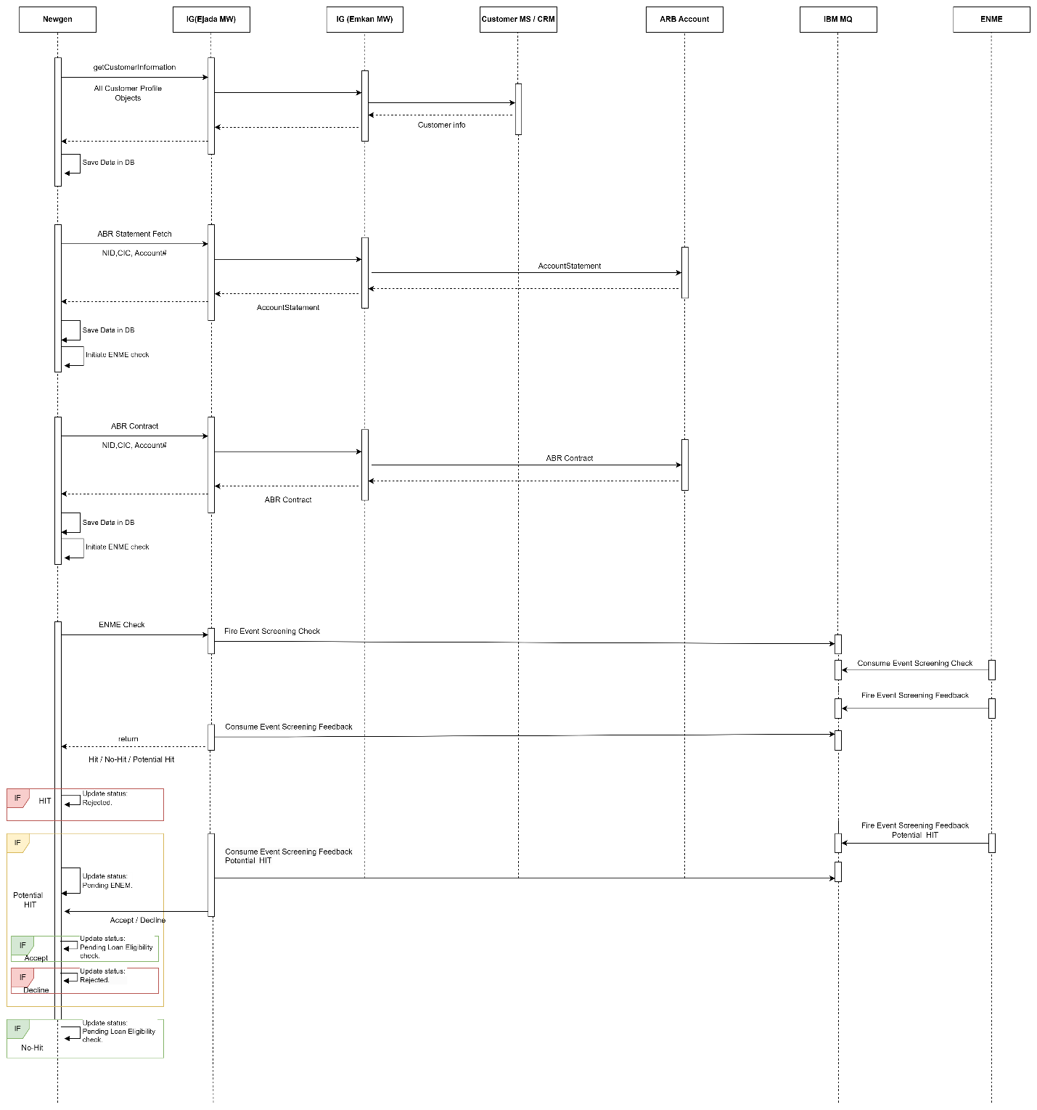

Get Application Status ( Newgen) :

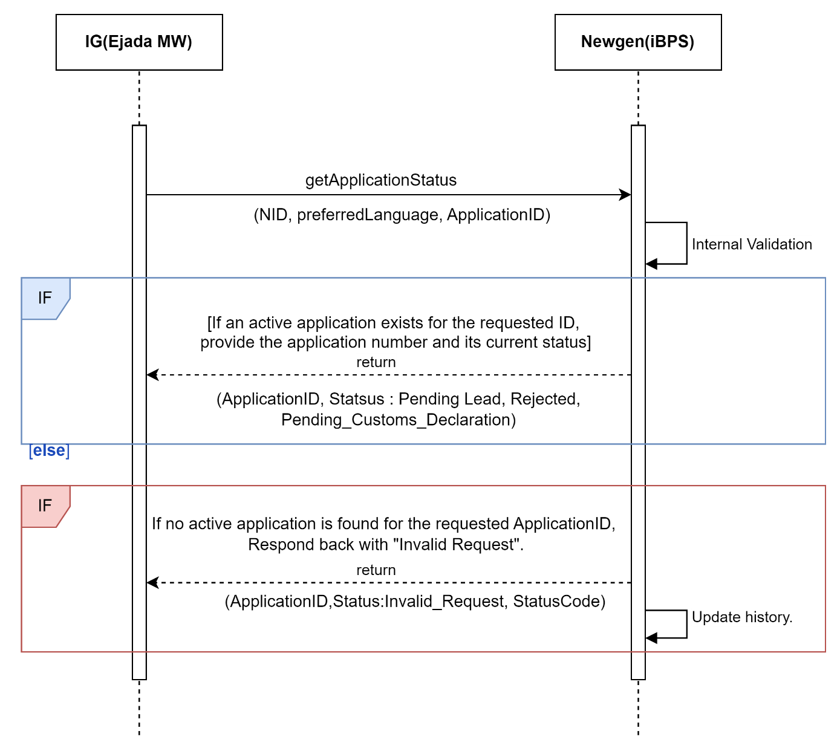
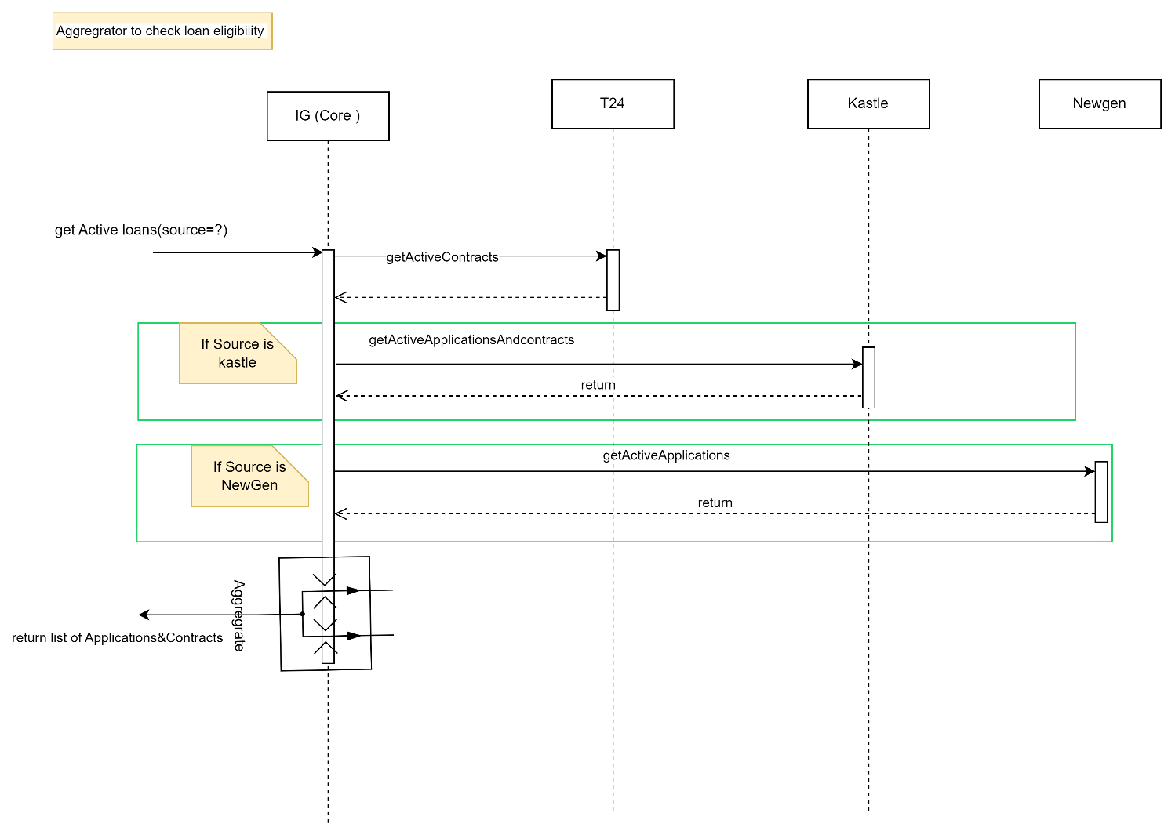

Description:

System Provider | Action | Request | Response | Type | Description
Loan-Origination | /getActiveContractsEligibileForRefinance | nationalId  preferredLanguage | Proceedflag  Reason  transactionId  refinanceApplications{  appId  subProductId  paidAmount  totalAmount  paidPercentage  isRecommended  } | Rest/Json
Loan-Origination | /createApplication | nid  emkanProduct  subProduct  preferredLanguage | compAppId,  stageStatus,  emkanProduct,  subProduct | Rest/Json
CoreSystem | LoanEligibility | Nid  productCode | proceedFlag | Rest/Json | Perform Loan Eligibility if eligible for Refinance
CoreSystem | getActiveApplications | Nid | Application information  contractId | Rest/Json | Get all details related to applications along with contractId
CoreSystem | getLoanInfoByContractId | Nid  contractId | Status,  Tenure,  totalInstallments,  remainingInstallments,  totalFinancingAmount,  remainingBalanceAmount,  lastInstallmentDate,  nextInstallmentDate,  apr,  excessAmount,  principleoutstanding,  profitoutstanding,  totalprofitdue,  earlyterminationfees,  remainingunpaidinstallment,  paymentschedule  {  Applicationno,  installmentAmount,  principalAmount,  pricipalpaid,  profitAmount,  profitPaid,  dueDate,  installmentNo,  status  } |  | Fetch Loan information and perform Refinance Eligibility check AS IS.
Loan-Origination | getApplicationStatus | Nationalid  compAppId  preferredLanguage | compAppId,  stageStatus,  emkanProduct,  subProduct |  | Based on status navigate to respective screen.

Customer declaration s2
- Diagram

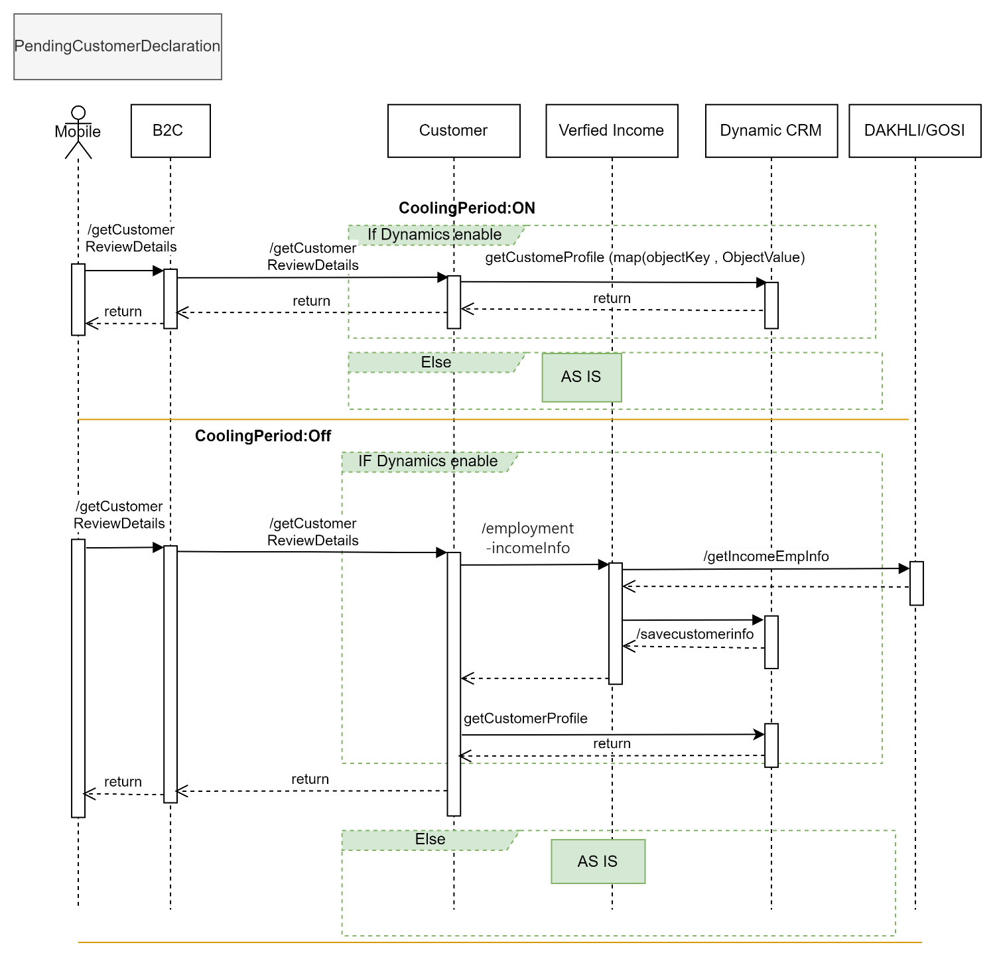

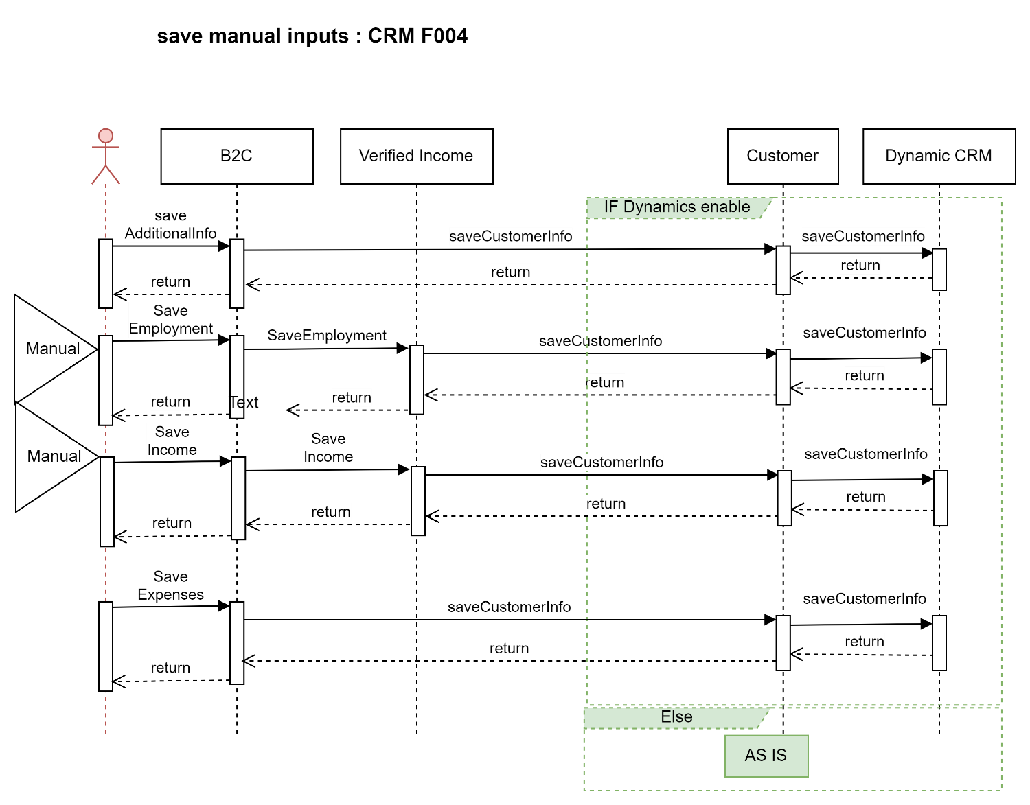

Description:

System Provider | Action | Request | Response | Type | Description
Customer | /getCustomerReviewDetails | "nid": "1184113444",  "compAppId": "1",  "dateOfBirthHijri": "1440-02-01"  "getCustomerInfo" : ["basicCustInfo","addInfo","salInfo","expInfo","empInfo","autoLeaseCustomerInfo","arbAccounts","ibanInfo","buyOutInfo","naInfo","companyInfo","loanDetails"] | "addInfo": {  },  "salInfo": [  {  }  ],  "expInfo": {  },  "empInfo": {  },  "autoLeaseCustomer": {  },  "arbAccounts": [],  "naInfo": {  "Addresses": [  {  }  ]  },  "compInfo"  "loanDetails":[  {  }]  ibanInfo:  {  }  "basicCustInfo": | Rest/Json | Internally calls api from CRM to fetch customer related information.
CRM | getCustomerProfile | Nid  "getCustomerInfo" : ["basicCustInfo","addInfo","salInfo","expInfo","empInfo","autoLeaseCustomerInfo","arbAccounts","ibanInfo","buyOutInfo","naInfo","companyInfo","loanDetails"] | nationalId  arbcic  isArB  emkanCustomerInfo{  }  addInfo{  }  salInfo[  {  }  ]  expInfo{  }  empInfo  {  }  "naInfo": {  "Addresses": [  ]  }  arbAccounts  {  }  autoLeaseCustomer  {  } | Rest/Json | Fetch customer information from CRM DB.
Verified-Income | /employment-incomeinfo | asIs | asIs | Rest/Json | Fetch employment income information from third party when cooling period is off.
Customer | /saveAdditionalInfo | addInfo  "dataCategory": "addInfo",  "source": "M",  "info": {  "loanPurpose": "HMREN",  "maritalStatus": "MARRIED",  "familySize": "3",  "educationalFees": "1",  "houseOwner": "RENTH",  "workingStatus": "SAL",  "associateCode": "EMK00222",  "source": null,  "occupationId": "5",  "occupationName": null,  "politicalExposed": "1",  "otherOccupation": null  } | status | Rest/Json
CRM | /saveCustomerInfo |  | status |  | This api will be exposed by CRM to emkan. Emkan will call this api to save customer related information in Dynamic CRM.  Below objects will be passed as part of this request.  "basicCustInfo","addInfo","salInfo","expInfo","empInfo","autoLeaseCustomerInfo",ibanInfo","buyOutInfo","naInfo","companyInfo","loanDetails"
Customer | /saveIncome | salInfo  {  "source": "M",  "dataCategory": "incomeInfo",  "info": {  "basicSalary": 10000,  "housingAllowances": 2100,  "monthlyAllowances": 3000,  "extraIncome": 122  },  "nid": "{{nid}}"  } | status |  | This api will internally call /saveCustomerInfo api exposed by CRM.
Customer | /saveEmployment | empInfo  {  "nid":"1928403847",  "customerEmployment":  {  "fullName":"omar Ahmed",  "basicWage":"12000",  "housingAllowance":"2000",  "otherAllowance":"2000",  "employerName":"شركة ميد التجارية",  "dateOfJoining":"22/08/2020",  "workingMonths":"12",  "employmentStatus":"نشيط",  "salaryStartingDate":"2015/06/12 00:00:00.000",  "establishmentActivity":"",  "channel":"MANUEL",  "source":"M",  "sectorId":"GOV",  "departmentID":"MIN00006",  "militaryRank":"WAKEEL",  "active":1,  "updatedAt":"",  "manualCoolingPeriod":""  }  } | status |  | This api will internally call /saveCustomerInfo api exposed by CRM.
Customer | /saveExpenses | expensesInfo  {  "nid": "1662468493",  "source": "manual",  "dataCategory": "expInfo",  "info": {  "totalIncome": "244",  "housing": "22",  "expatFees": "22",  "foodBeverage": "22",  "tuitionFees": "22",  "healthcareInsurance": "2",  "transportationCommunication": "22",  "totalAdditionalExpenses": "22",  "totalObligations": "22",  "otherLoans": "false",  "otherLoansWithBank": ""  }  } | status |  | This api will internally call /saveCustomerInfo api exposed by CRM.

- >> Confirm KYC Completed
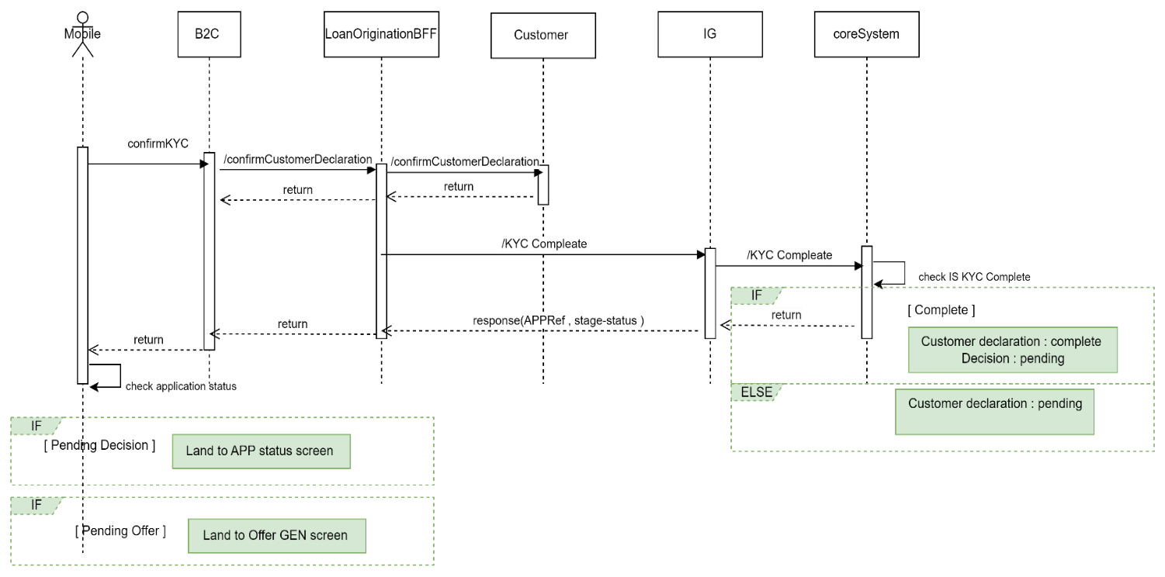

Description:

System Provider | Action | Request | Response | Type | Description
CoreSystem | /KycComplete | Nid  Status  applicationId  productCode | Nid  StageStatus  applicationId | Rest/Json | Update Kyc status in Newgen.  Before updating verify if KYC is completed.  If yes then update status to „Decision Pending“  Else  Have the status as “Customer Declaration Pending“
Loan-Origination | getApplicationStatus | nationalid  compAppId  preferredLanguage | compAppId,  stageStatus,  emkanProduct,  subProduct | Rest/Json | Based on status navigate to respective screen.

Qarar ( Newgen):

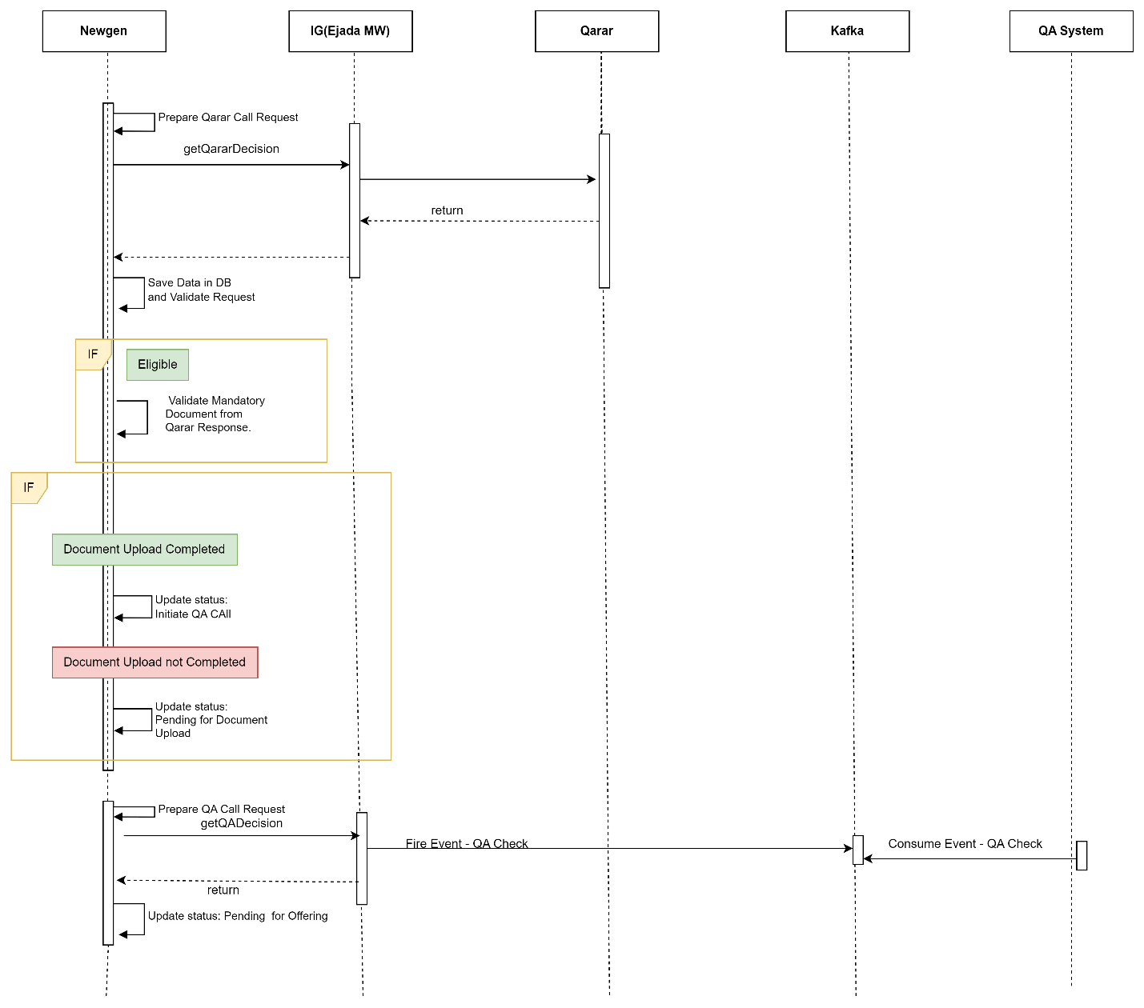

Upload Document Flow S3
Design Overview

- Diagram
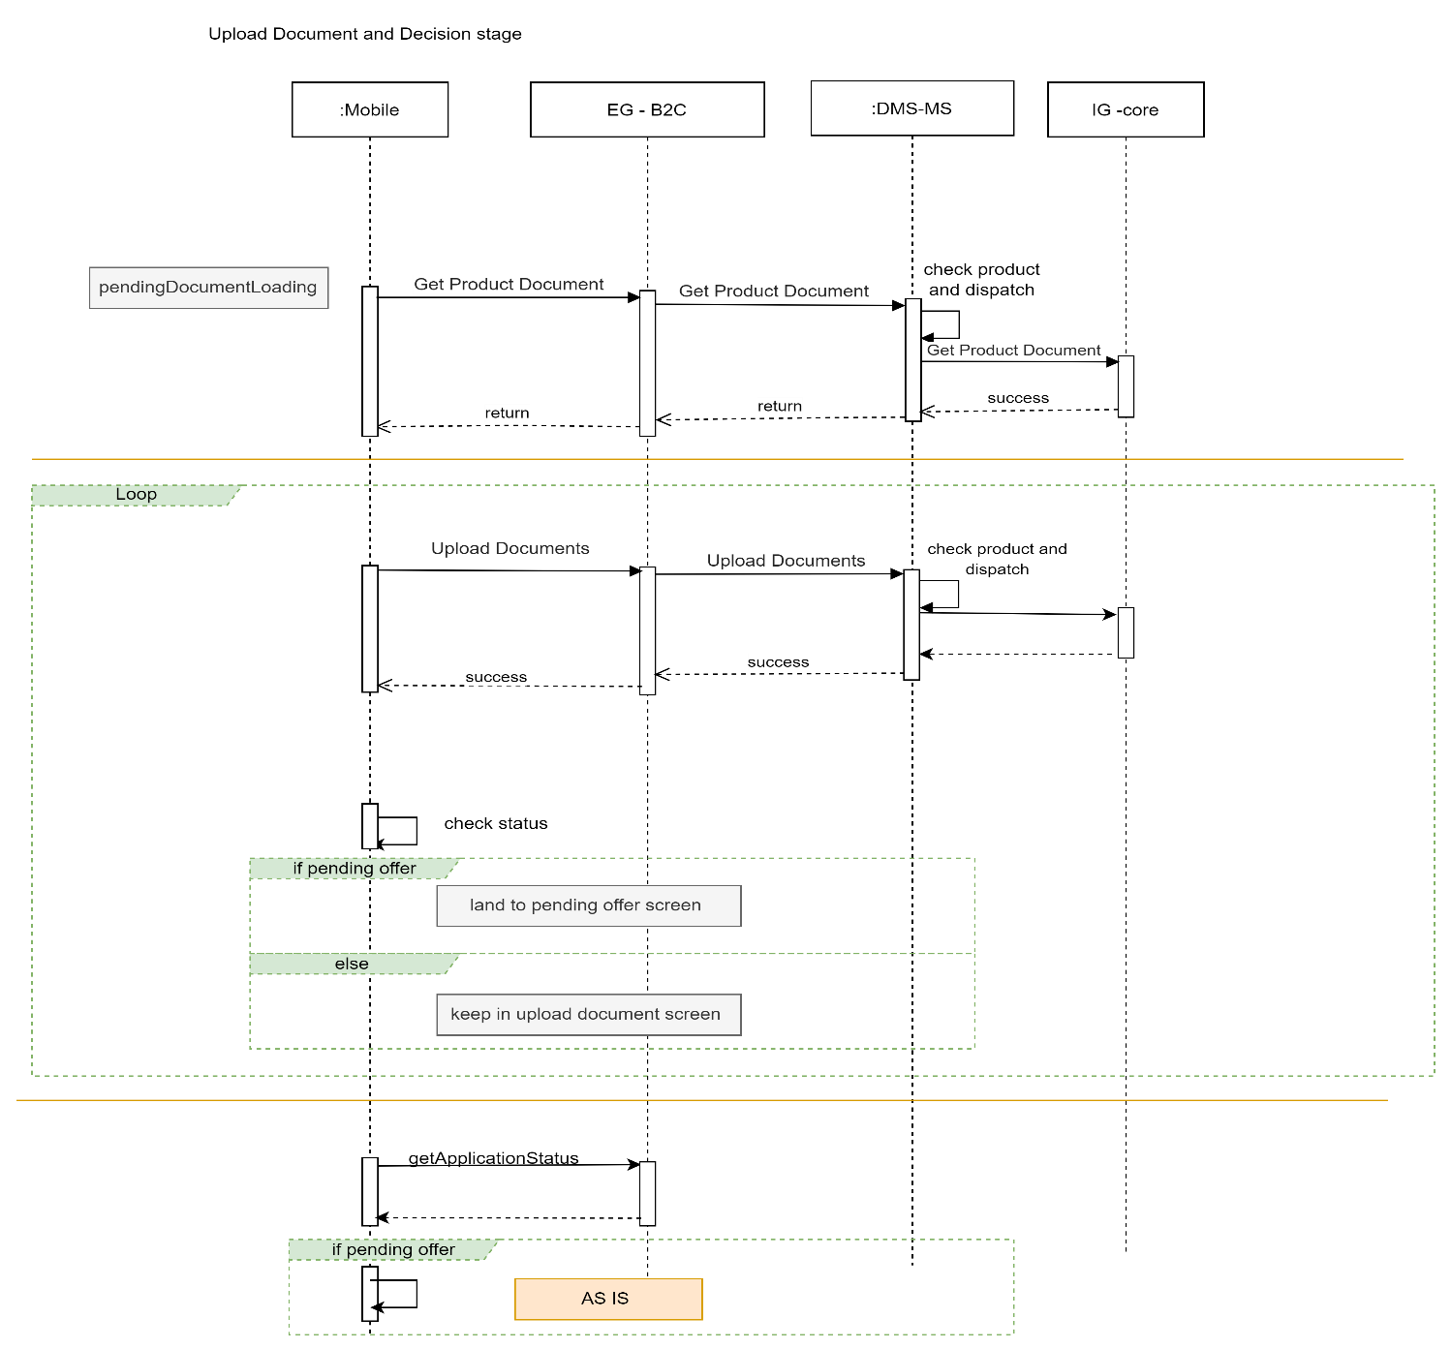

Document Upload (Newgen):

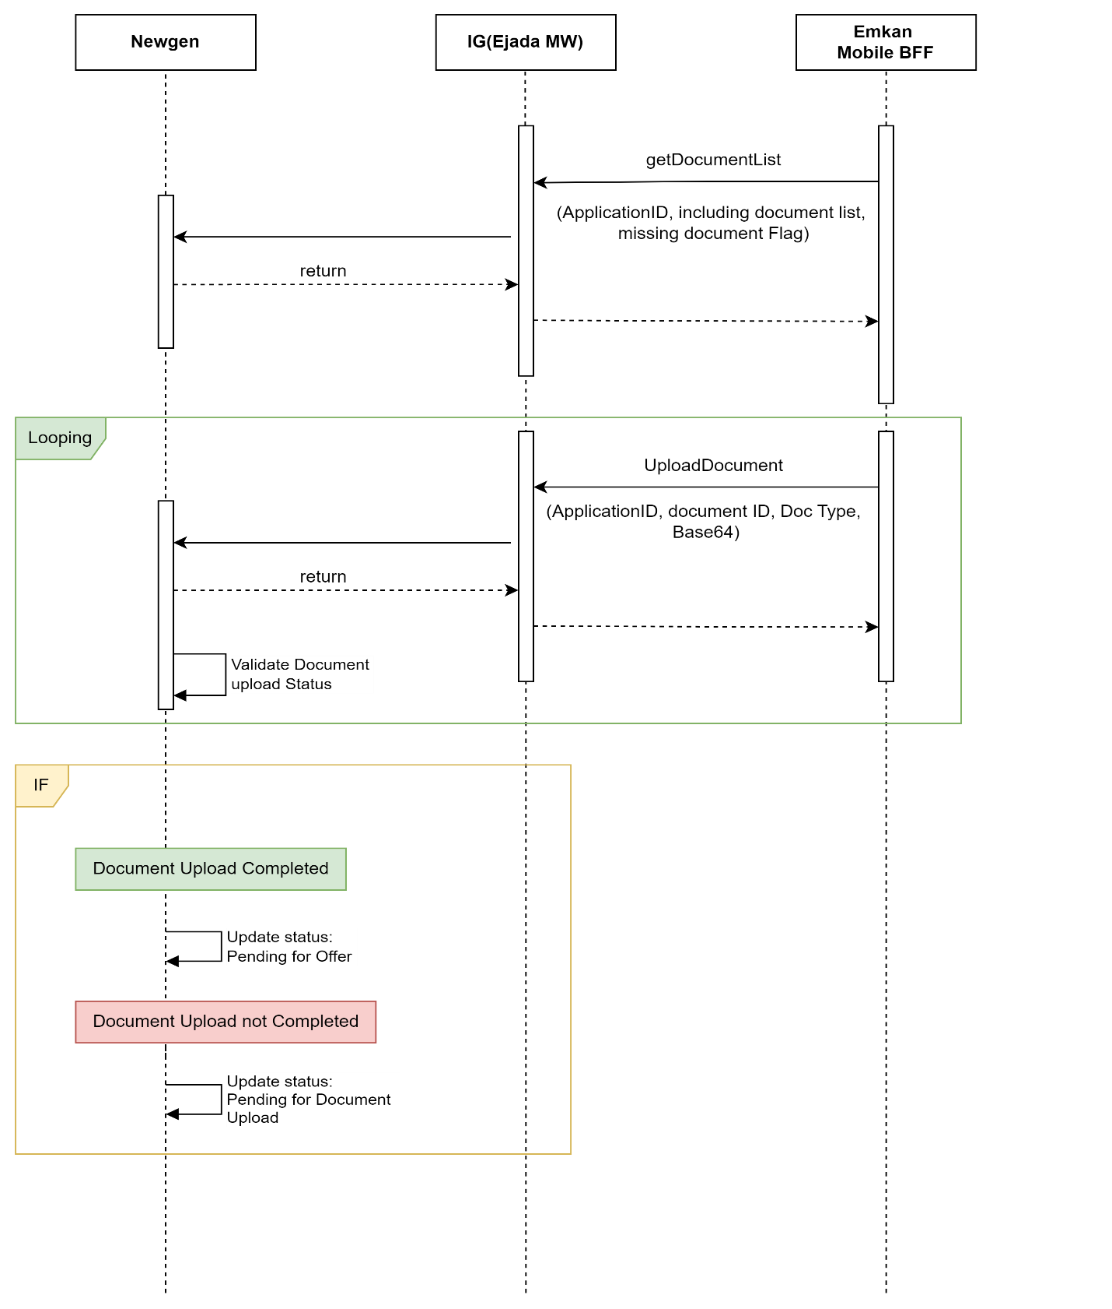

Description:

System Provider | Action | Request | Response | Type | Description
DMS | /getProductDocument | documentCode  cic  nationalId  source | source  documents  {  fileContent  filename  docId  } | Rest/Json
DMS | /uploadDocuments | compAppId  docId  replaceOrAddDoc  data  fileName | status  message  attachmentresponse  {  filename  uploadstatus  }
Loan-Origination | getApplicationStatus | nationalid  compAppId  preferredLanguage | compAppId,  stageStatus,  emkanProduct,  subProduct |  | Based on status navigate to respective screen.

Quality Flow

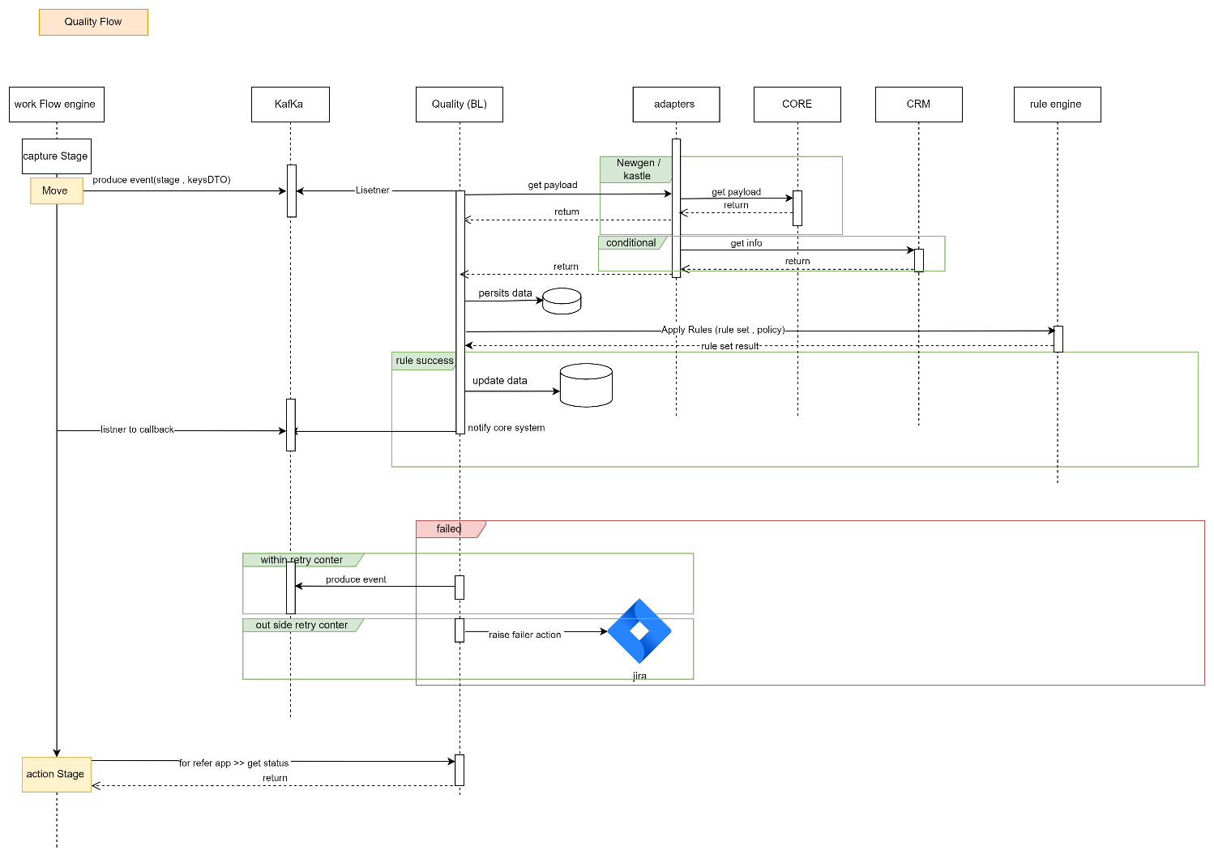

Description:

System Provider | Action | Request | Response | Type | Description
Kafka | /send/{topic}  Topic Name: QTY.QUALITY_EVENTS | eventCode  captureStageKey(Create Application)  compAppId  nationalId  emkanProduct  source |  | Kafka Queue | Push request to Kafka Topic  Topic Name: QTY.QUALITY_EVENTS
Quality-Control | /status | eventCode  stageKey  compAppId  nationalId  containerId  emkanProduct | message  action  containerName  captureStage
Kafka | /callback/{ QTY.QUALITY_EVENTS_CALLBACK} | compAppId  nationalId  emkanProduct  status  source

Offering Flow

- Initial Offer
Design Overview

- Diagram
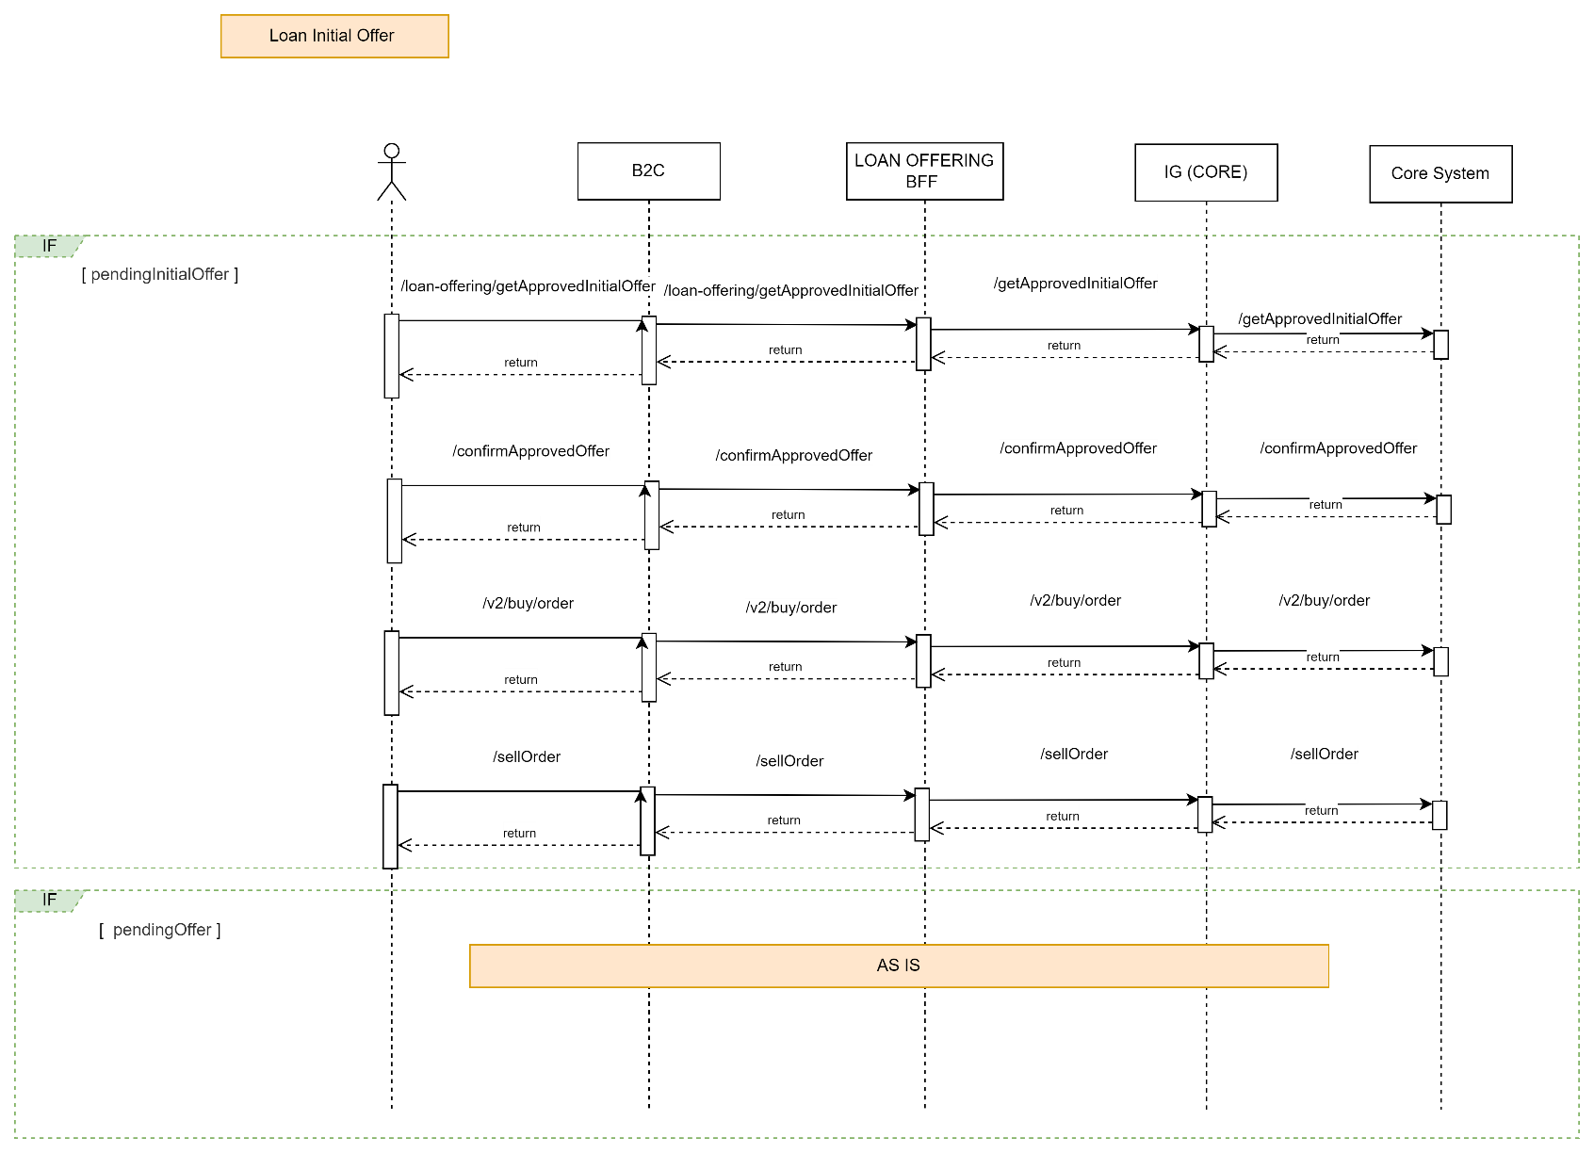

Description:

System Provider | Action | Request | Response | Type | Description
Loan-Offering | /getApprovedInitialOffer | nationalId  compAppId  preferredLanguage | compApplId  requestFinanceAmount  offerFinanceAmount  currency  purchasePrice  totalDownPayment  profitAmount  totalFinanceAmount  financeAmount  minimumFinanceAmount  maximumFinanceAmount  installmentAmount  extraAmount  apr  flatRate  debitAmount  tenure  minimumTenure  maximumTenure  minimumAmount  maximumAmount  managementFees  totalFees  vat  commodityFees  subProductCode  voucherAmount  totalAmountWithProfit  deferredLoan  deferredMessage | Rest/Json
Loan-Offering | /confirmApprovedOffer | AsIs | AsIs
Loan-Offering | /v2/buy/order | AsIs | AsIs
Loan-Offering | /sellOrderForRefinance | AsIs | AsIs

- Final Offer

Design Overview

- Diagram

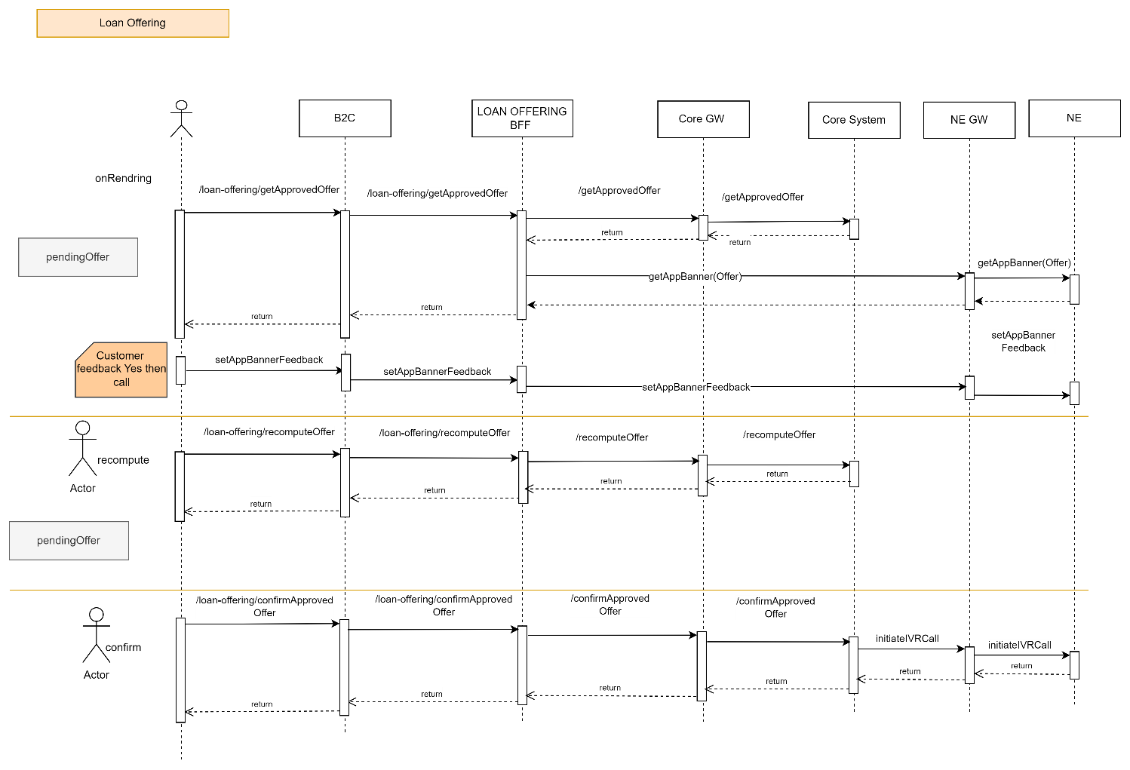

Description:

System Provider | Action | Request | Response | Type | Description
Loan-Offering | /getApprovedOffer | AsIs | AsIs | Rest/Json
Loan-Offering | /recomputeOffer | AsIs | AsIs | Rest/Json
Loan-Offering | /confirmApprovedOffer | AsIs | AsIs | Rest/Json

IVR Flow

Mobile Flow

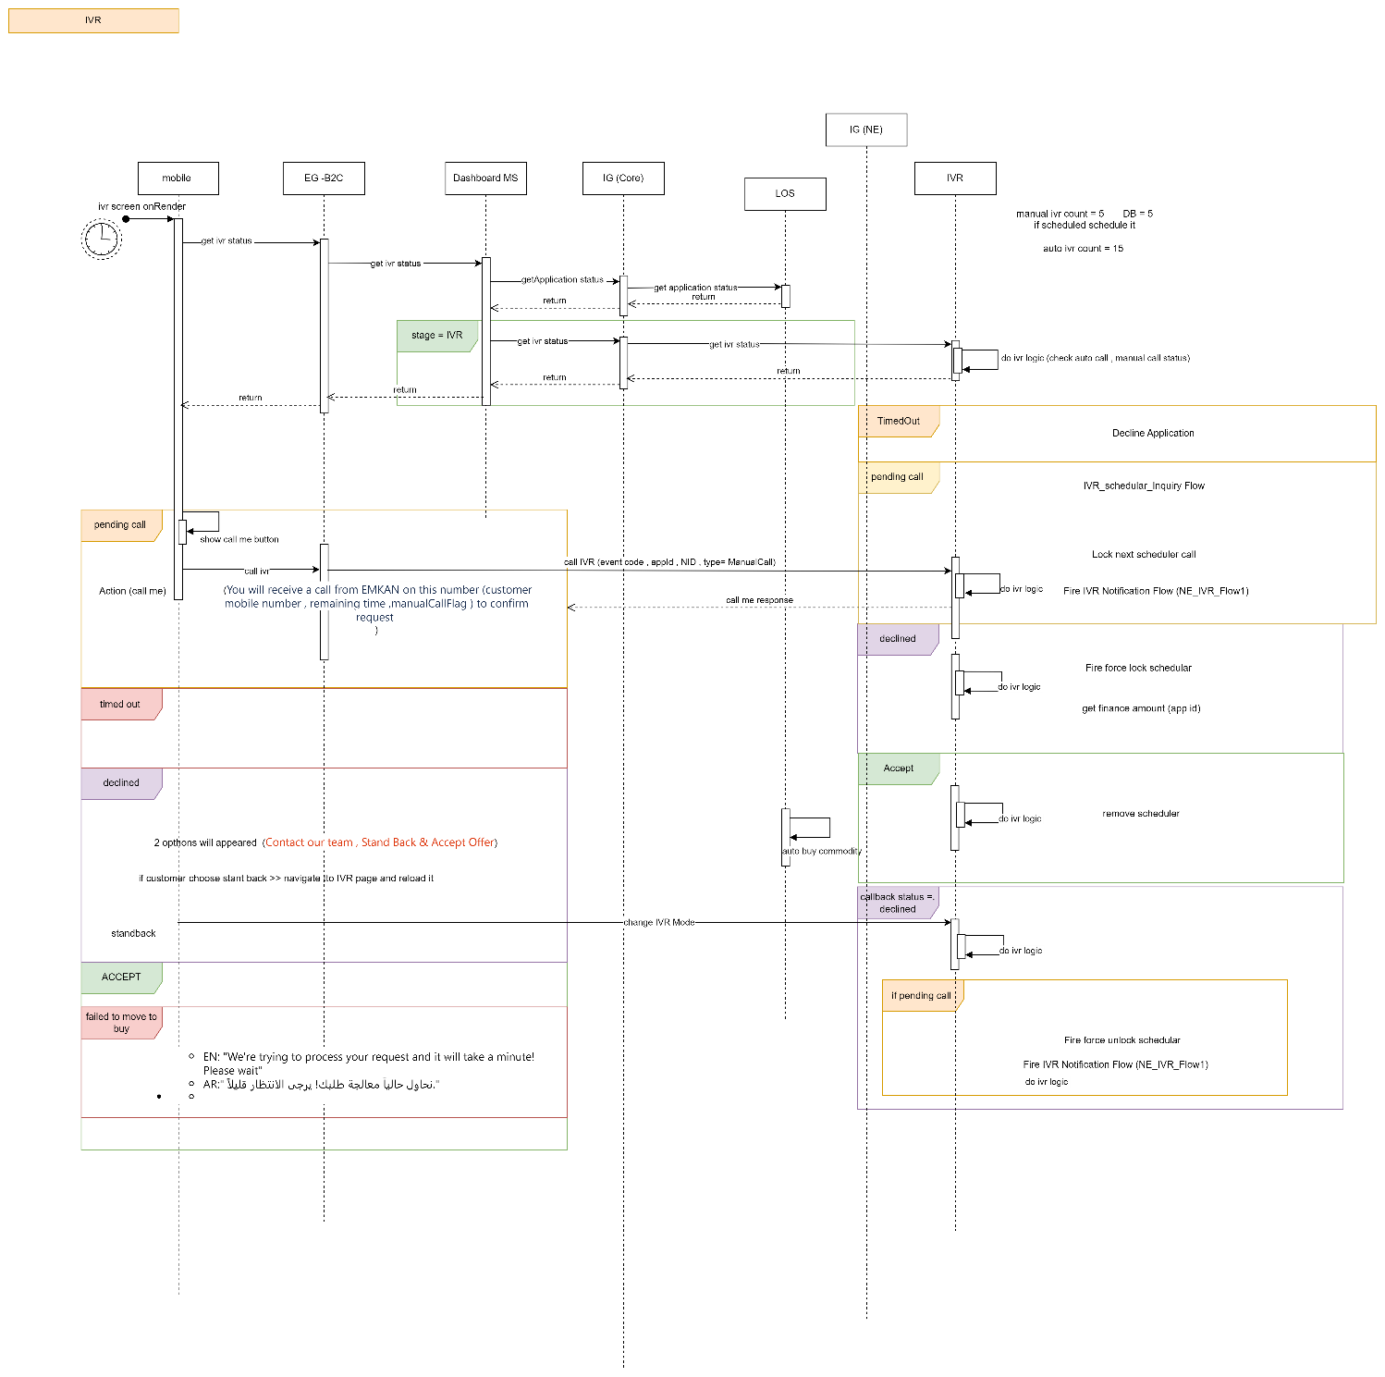

Callback Flow:

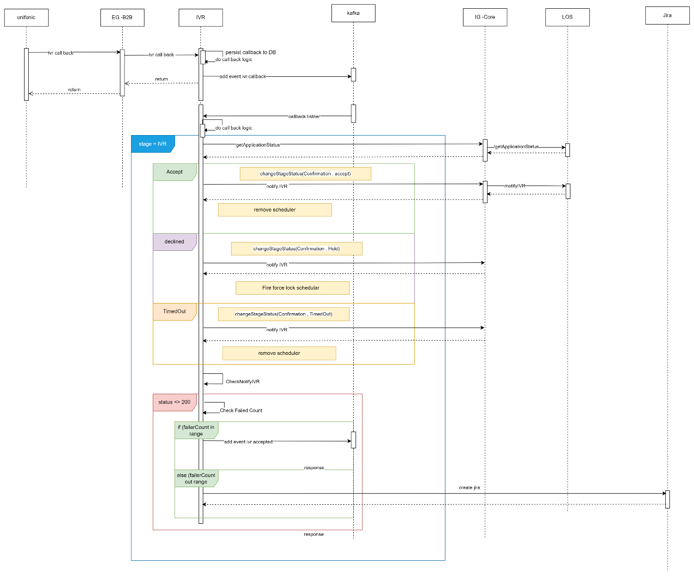

Description:

System Provider | Action | Request | Response | Type | Description
IVR | /getIVRStatus | AsIs | AsIs | Rest/Json
Loan-Origination | getApplicationStatus | nationalid  compAppId  preferredLanguage | compAppId,  stageStatus,  emkanProduct,  subProduct |  | Based on status navigate to respective screen.

BuyCommodity Flow

Design Overview

- Diagram

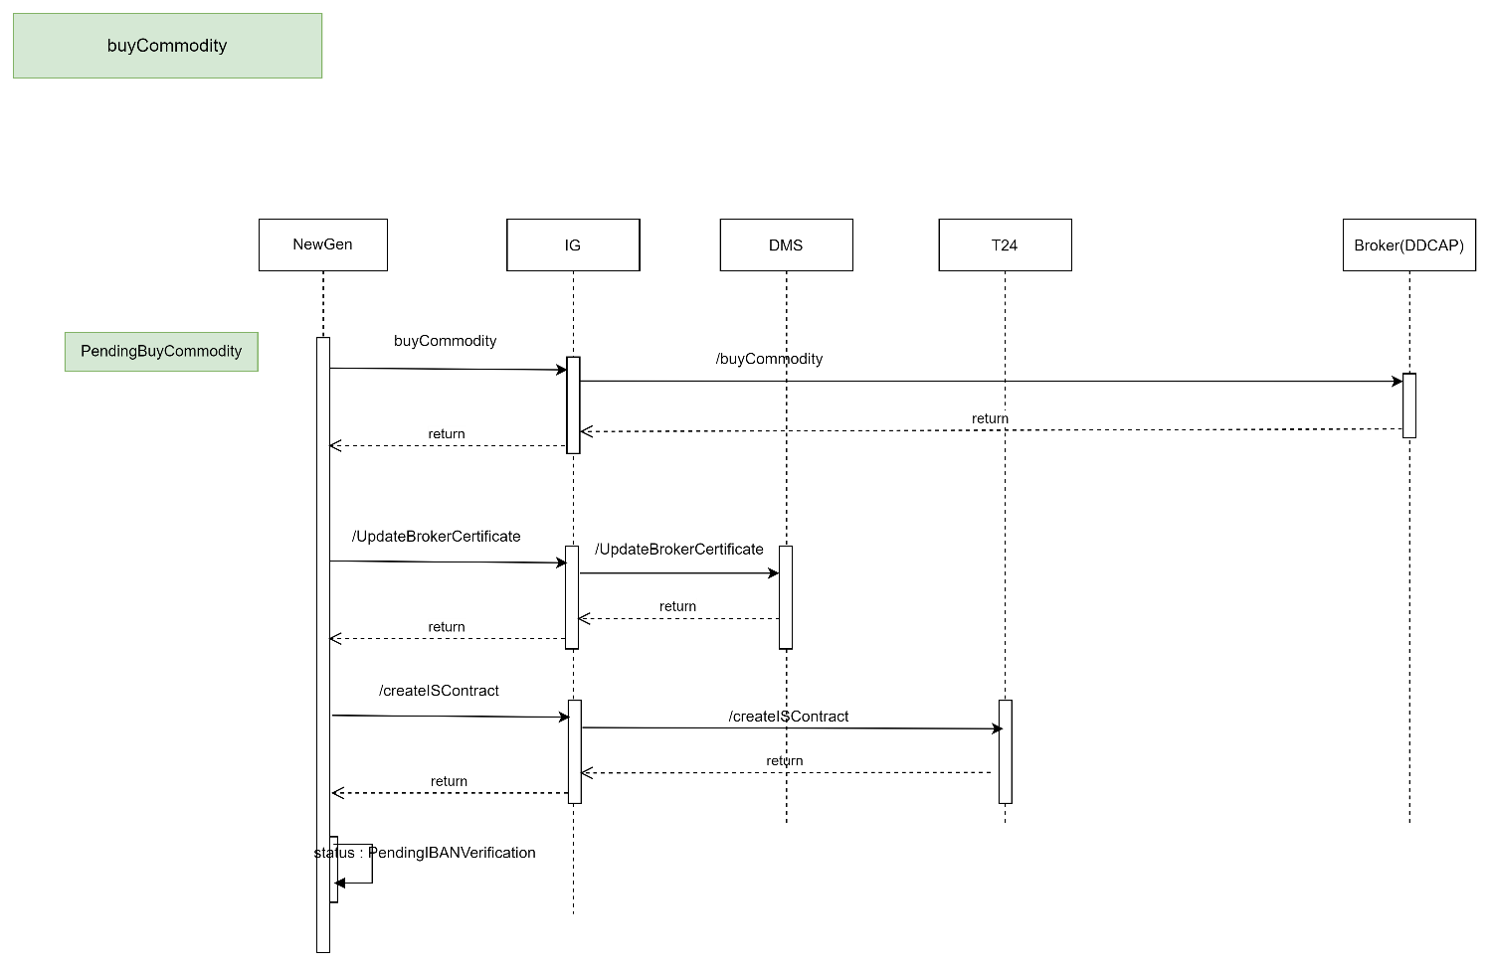

Description:

System Provider | Action | Request | Response | Type | Description
NewGen | buyCommodity | AsIs | AsIs | Rest/Json
NewGen | updateBrokerCertificate | AsIs | AsIs | Rest/Json
T24 | createIslamicContract | AsIs | AsIs
NewGen | updateStatus |  |  |  | Post succesful purchase of commodity, Newgen to update status to pendingIbanVerification.

- NewGen Diagram

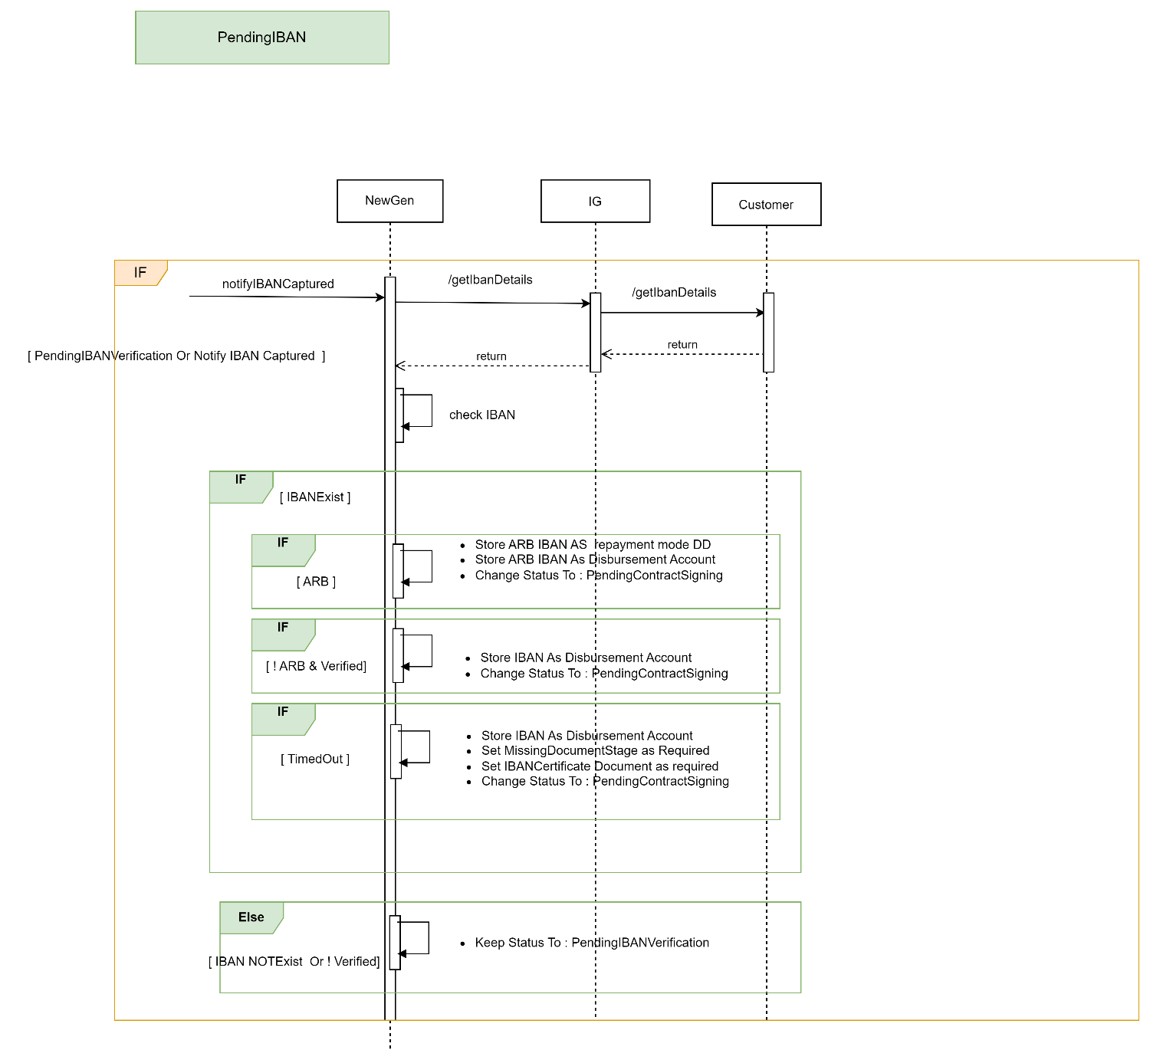

Description
System Provider | Action | Request | Response | Type | Description
Newgen | /getIbanDetails | NID  ApplicationId | Status  NID  ibanNumber  active  bankCode  status  primaryIban  verifiedFlag  isARB | Rest/Json | 1) Newgen to call /getIbanDetails to fetch verified ibans from DB.  2) Once iban information is gathered. Newgen to update repayment mode and disbursment account and status accordingly.

IBAN Verification Flow

- Mobile Diagram
- 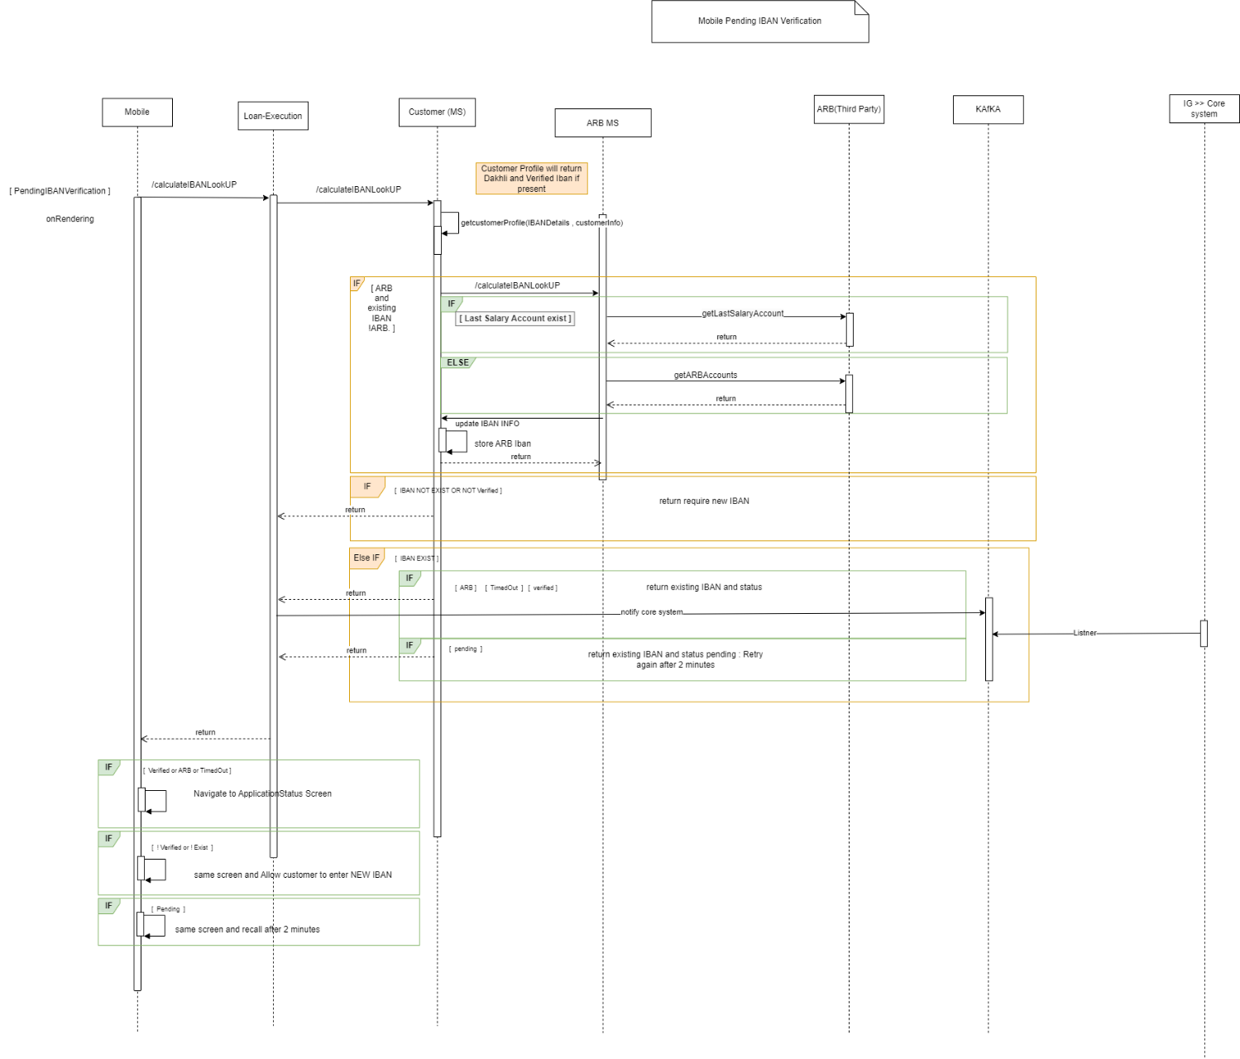

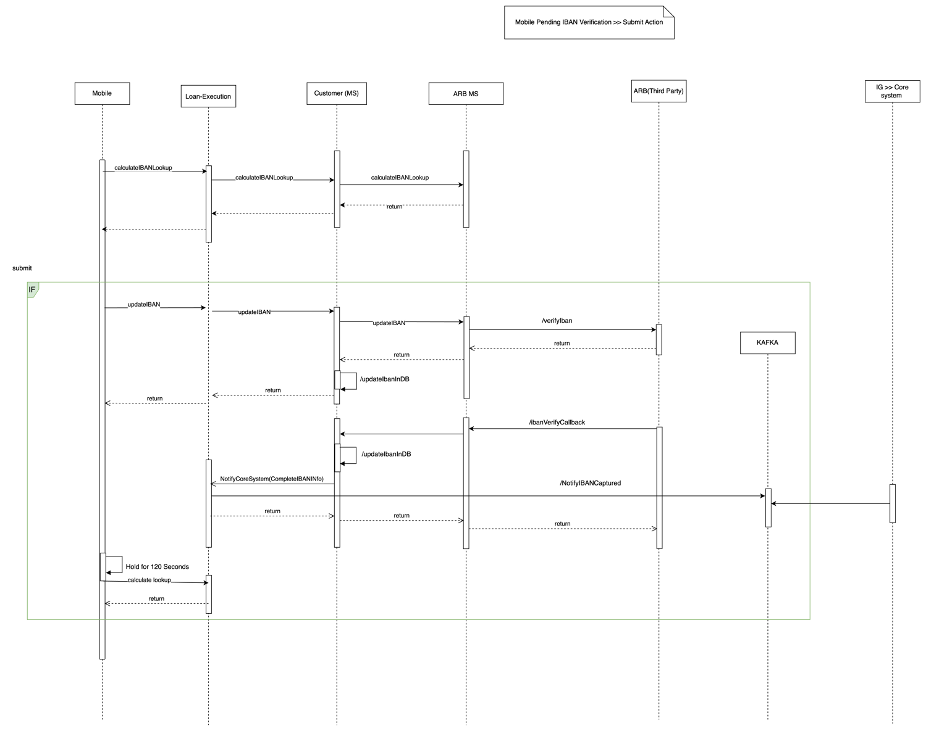

Description

System Provider | Action | Request | Response | Type | Description
Customer | getCustomerProfile | NID | nationalId  ibanNumber  active  bankCode  status  primaryIban  verifiedFlag  isARB  CustomerProfileInfo | Rest/Json | 1) This api will fetch all customer information along with Iban information.  2) During fetching Iban information below priority should be followed.  i) If ARB iban exists return the same.  ii) If Verified Iban exists in iban_verification return the same.  iii) If dakhli iban exists return the same.
Loan-Execution | /calculateIBANLookUp | NationalId  ApplicationId | nationalId  ibanNumber  active  bankCode  status  primaryIban  verifiedFlag  isARB | Rest/Json | 1)Verify if isARB flag for customer  2) If isARB is true for customer fetch ARB accounts.  If Last Salary account exists then return the iban info and notify core system and navigate to ApplicationStatus screen.  Else fetch Arb accounts and return 1st account by default and notify core system and navigate to ApplicationStatus screen.  3) If ARB does not exist and verified Iban exists then return existing iban with status verified and notify core system and navigate to ApplicationStatus screen.  4) If iban verification is pending then return existing iban with status as pending and message as – “Retry after 2 mintues“.(Configurable)  5) If iban verification is “TimedOut“ then notify core system with status as TimedOut and navigate to ApplicationStatus screen.  6) If iban status is Verified or ARB or TimedOut then Navigate to ApplicationStatus screen.  7) If iban status is not verified or not exist then allow customer to enter New Iban on same screen.  8) If iban status is pending then recall after 2 minutes.
ARB | getLastSalaryAccount | NID  arbCIC | isARB  accountNumber  iban  bban  accountName  accountStatus  accountOpeningDate  accountClosingDate | Rest/Json | If Last Salary account is present then return this response
ARB | getARBAccounts | NID  arbCIC | isARB  accountNumber  iban  bban  accountName  accountStatus  accountOpeningDate  accountClosingDate | Rest/Json | Return list of ARB accounts and by default pick the first record.
Customer | updateIban | NID  IBAN | NID  verifiedFlag  iban  bankCode  active  status  primaryIban  accountNumber | Rest/Json | Enter Non ARB iban from screen.  Save iban in iban_verification table.  Mark primaryIban as Y
ARB | /verifyIban | Iban  poiType  poiNumber  source  IbanMetaDto  {  Name  Value  } | AsIs | Rest/Json | Please refer request and response from Sarie microservice.  /verifyIban
ARB | /ibanVerifyCallBack | AsIS | AsIS | Rest/Json | Callback recieved from ARB.  Update callback information in DB.
Customer | updateIbaninDB |  |  |  | 1) Update iban information into DB once verifyIban is completed.  2) Update iban information in DB once callback recieved from ARB
Loan-Execution | /NotifyCoreSystem | NID,  ApplicationId,  “actionRequired": "IBAN_FETCH_INITIATED" | success |  | Once callback was received succesfully. Notify Newgen through Kafka.
Kafka | NotifyIbanCaptured | NID,  ApplicationId,  “actionRequired": "IBAN_FETCH_INITIATED" | success | Kafka queue | Once callback was received succesfully. Notify Newgen through Kafka.
IG>>Newgen | ListenertoKafka | NID,  ApplicationId,  “actionRequired": "IBAN_FETCH_INITIATED" | success | Kafka Queue | Ejada MW will Listen to Kafka and notify core system accordingly.
Newgen | /getApplicationStatus | NID  ApplicationId | Status |  | 1) Mobile will hold for 120 seconds(configurable) post updateIban.  2) Get latest status from Newgen and proceed based on the status.

ContractSigning Flow
Design Overview

- Diagram
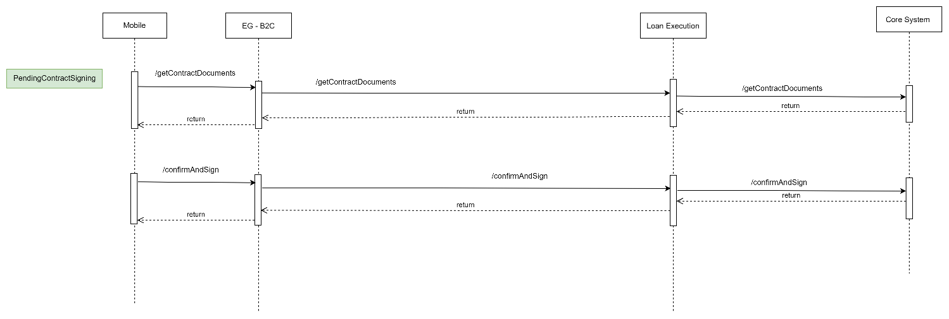

Description
System Provider | Action | Request | Response | Type | Description
Loan-Execution | getContractDocuments | AsIs | AsIs | Rest/Json
Loan-Execution | /confirmAndSign | AsIs | AsIs | Rest/Json

Signe Flow

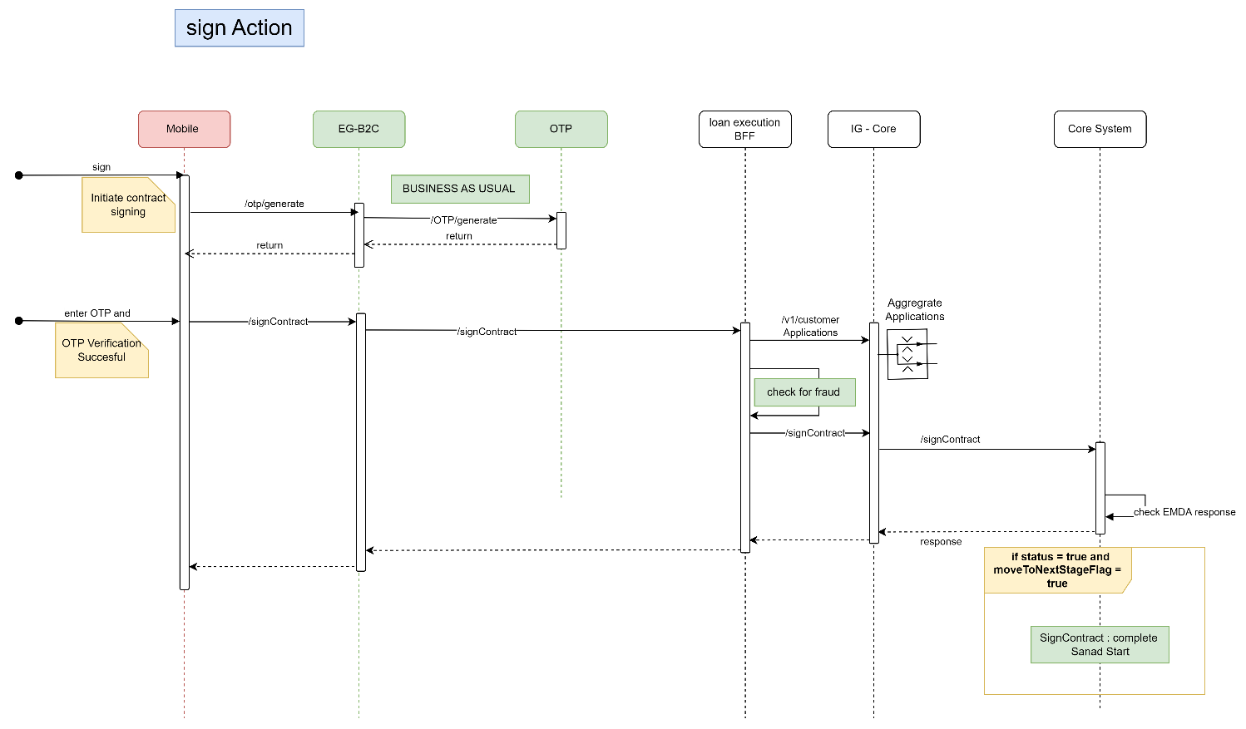

Description:

System Provider | Action | Request | Response | Type | Description
OTP | /otp/generate | AsIs | AsIs | Rest/Json
Loan-Execution | /signContract | nationalId  compAppId | compAppId  status  isSanad  sanadURL

Sanad Flow
Design Overview

- Diagram

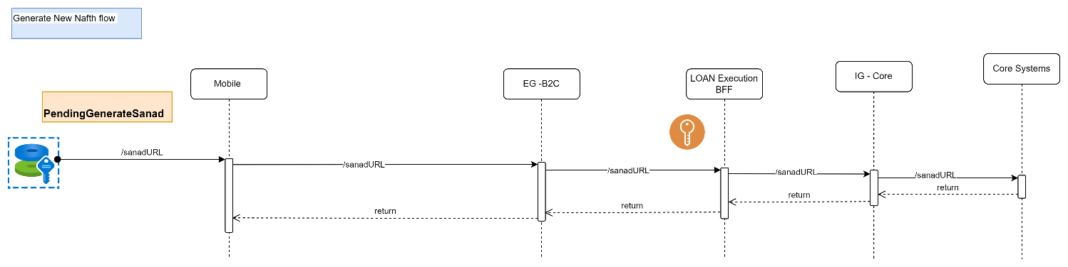
Description:

System Provider | Action | Request | Response | Type | Description
Loan-Execution | /sanadURL | status  isSanad  sanadURL | status  isSanad  sanadURL

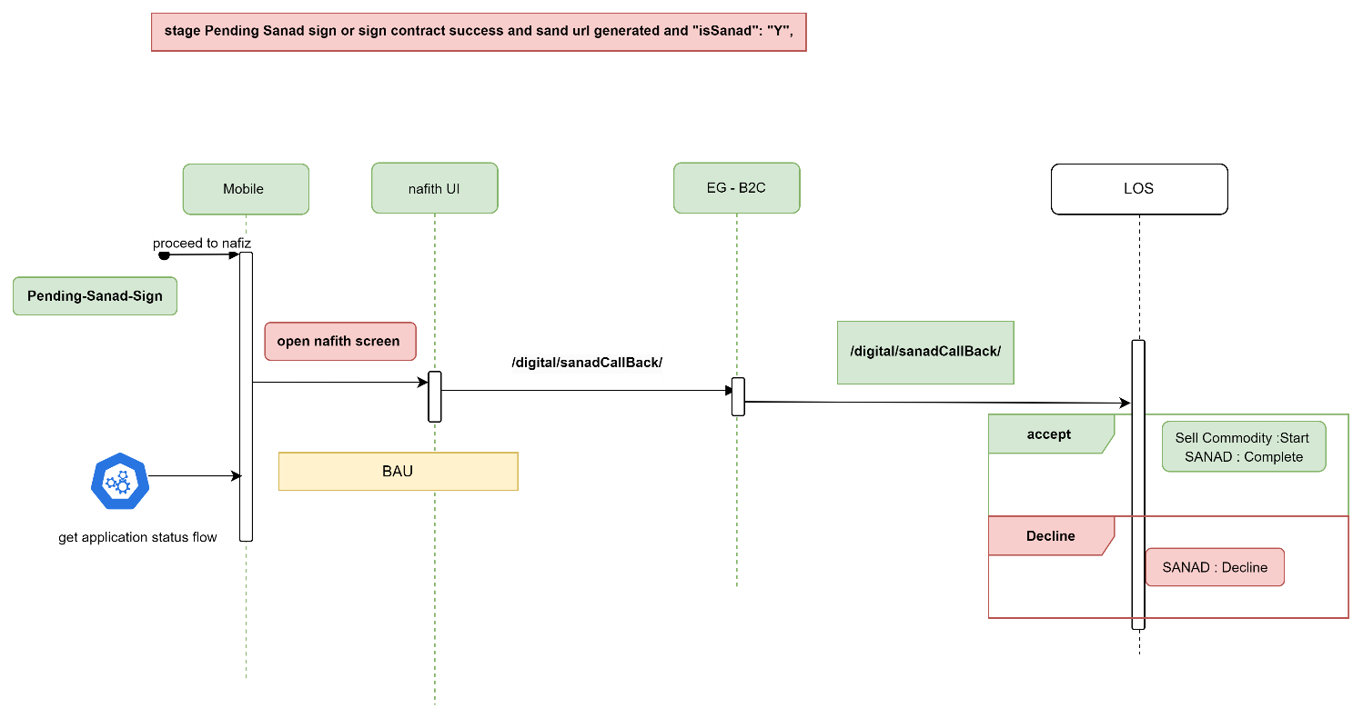

Description:

System Provider | Action | Request | Response | Type | Description
Loan-Execution | /digital/sanadCallBack | AsIs | AsIs

view sale authorization Flow

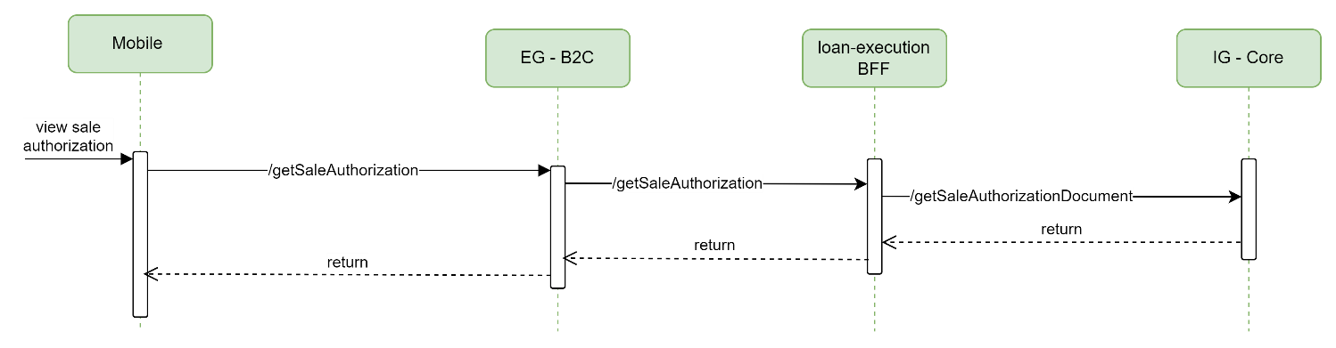
Description:

System Provider | Action | Request | Response | Type | Description
Loan-Execution | /getSaleAuthorization | AsIs | AsIs

Sell commodity Flow
Design Overview

- Diagram
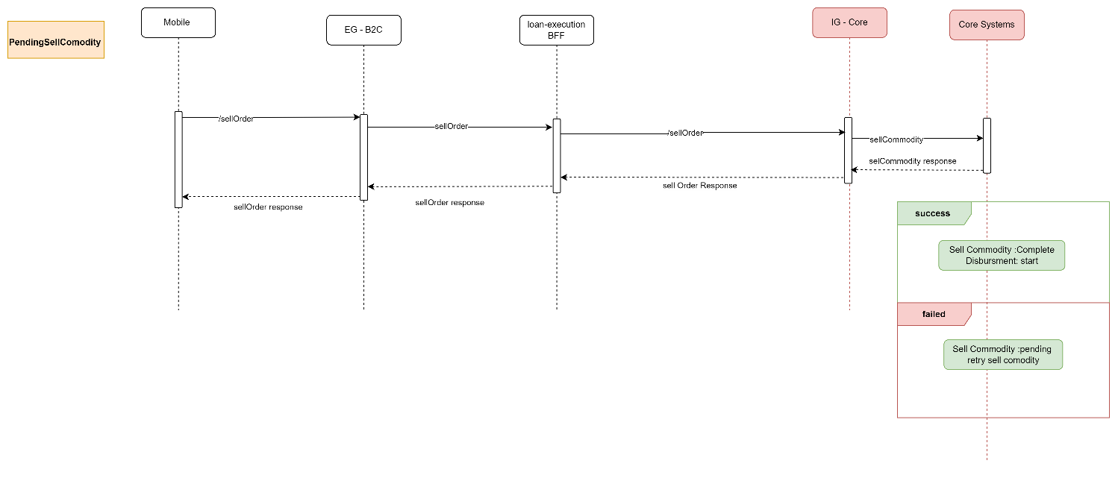

Description:

System Provider | Action | Request | Response | Type | Description
Loan-Execution | /sellOrder | nid  compAppId | compAppId  status

Disbursment Flow
LOS internal Flow

MissDocument Flow

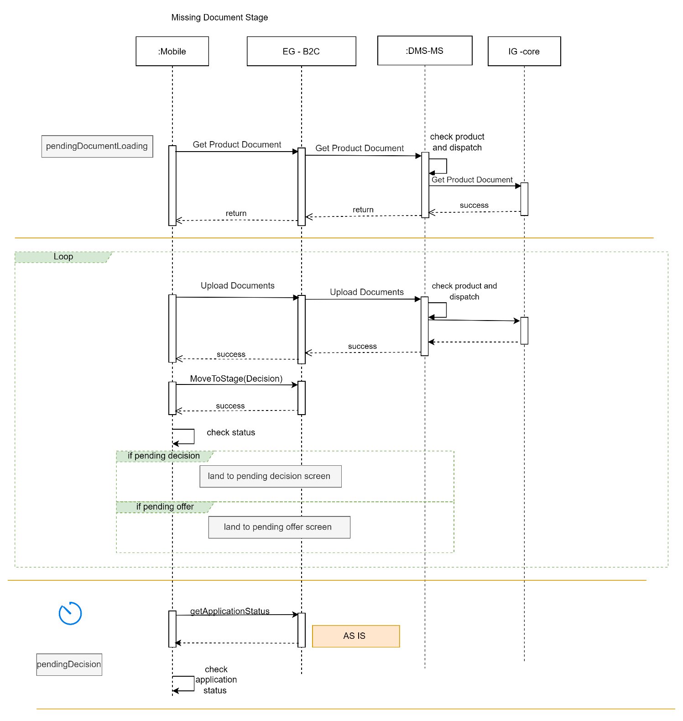

Deployment and Security View

Description:

System Provider | Action | Request | Response | Type | Description
Loan-Origination | getApplicationStatus | Nationalid  compAppId  preferredLanguage | compAppId,  stageStatus,  emkanProduct,  subProduct |  | Based on status navigate to respective screen.
DMS | getProductDocument | AsIs | AsIs
DMS | uploadDocument | AsIs | AsIs

Payment Info:

Diagram
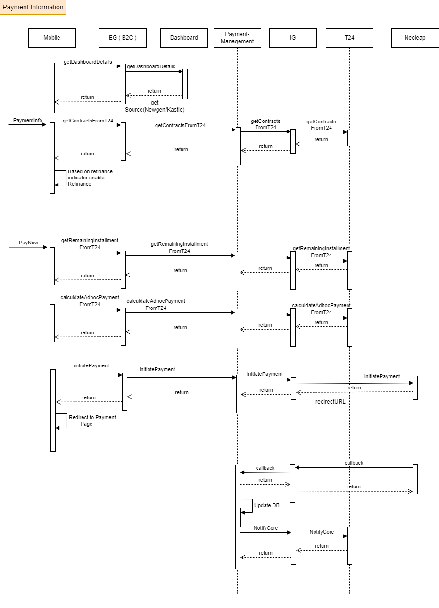
Description:

System Provider | Action | Request | Response | Type | Description
Dashboard | getDashboardDetails | AsIs | AsIs | Rest/Json | Dashboard should fetch all application information from all core systems.  As mentioned in above diagrams.  It should also return source as Newgen/Kastle
Payment-Management | getContractsFromT24 | Nid  applicationId  source  subProduct | financingId: 12333  repaymentTracker: 30  totalFinancedAmount:132904.6  currency:SAR  nextSadadBillNo:  sadadBillPaymentFlag:  installmentAmount:2215.08  lastInstallmentDate:27/01/2027  nextInstallmentDue:27/07/2024  dateFormatOfNextInstallmentDueDate:G  dateFormatOfLastInstallmentDueDate:G  installmentsRemaining:42  amountRemaining:93033.16  status:open  extraFinanceAmount:null  loanType:Top-up  refinanceIndicatorResponse:  {  Eligible:true  refinanceAmount:608272.59  totalContractValue:834953.4  profitRate:0.0399  monthlyInstallment:13915.89  code:REF  name:Refinance  tenure:60  profitAmount:120000} | Rest/Json | This api is used to display payment information.  Also this api will let us know if user is eligible for refinance. If eligible it will pass all refinance related information as part of response.
Payment-Management | getRemainingInstallments | contractId  requestType:Normal Payment  nid | remainingNumberOfInstallmentList:[1,2,3,4,5] | Rest/Json | When user clicks on Pay now this api is called to fetch remaining Number of Installments.
Payment-Management | calculateAdhocPayment | contractId:  requestType:Normal Payment  nid :  numberOfSelectedInstallmentsToSettle:2  productCode: PF | totalDueAmount:4430.16  remainingDue:88603.0  settlementPeriod:27-AUG-23 – 27-SEP-23  remainingInstallment:40  calculationId: null | Rest/Json | This api is called when user select installment number from above api and proceed.  Then remaining calculated amount is desplayed.
Payment-Management | initiatePayment | contractId:  requestType:Normal Payment  nid :  numberOfSelectedInstallmentsToSettle:2  productCode: PF  accountReference:  paymentAdditionalDetails:[  {  paymentId:  paymentOption:  moneySourceLookupCode:  moneySourceUserInput:  isCardOwner:  cardOwnerName:  relationWithCardOwner:  earlySettlementReasonLookupCode:  earlySettlementReasonUserInput: | redirectionUrl  paymentReferenceNumber  paymentId |  | User will be redirected to redirectionUrl provided by the Neoleap.
Payment-Management | Callback | Result:[  errortText,  error,  status]  responseUrl,  payload:  {  Date,  authRespCode,  authCode,  cardType,  transId,  trackId,  applicationId,  productCode,  paymentType,  paymentId,  nationalId,  preferredLanguage,  accountReference,  totalAmountOfBill,  amt,  ref,  paymentTimeStamp  }  type | Status | Rest/Json | This callback will be received from Neoleap to Payment Management System.

Appendix A - Architectural Decisions

Appendix D – Failing Retry Policy
System | Error Code | Retry Mechanism | Max Number of Retry | Alternative after Pass Max No of Retry
Emkan Services | Not http “200” | Exponential back off  Starting with interval 5 mins | 20 | Create Jira ticket
“Newgen”,MW | Not http “200” | Retry every 10 min | 20 | Create Jira ticket

Appendix E – Cooling Period

Stage/Type | Cooling Period | System Owner
IVR
signing contract | 24 h
generate Sanad
Sanad approval | 24 h
commodity sales maker | 24 h
commodity delivery
document custody

Appendix H – Retention Policy

Stage/Type | online | Archive | Delete
Lead Applications | 10 day | 60 day | Yes
App Data Entry | 30 day | 60 day | Yes
Offering | 30 day | 90 day | No
Contract Sign | 30 day | 90 day | No
Closed/Rejected Application | 60 day | 60 day | No
Remittance Contract | 10 day | 60 day | No

Data Type | Retention Period | Reason | Action
Customer Transaction Data | 1 years | Legal requirements (e.g., FINRA), financial auditing, fraud prevention | Archive
Payment Card Data | 3 years | PCI DSS compliance, fraud prevention | Archive
Customer KYC (Know Your Customer) Data | 1.5 years | Legal requirements, anti-money laundering | Archive
Financial Reports | 2 years | Legal requirements, financial analysis | Archive
Employee Data | 1.5 years | Legal requirements, human resources management | Archive
Security Logs | 1 years | Security, compliance, troubleshooting | Archive
Logs and Audit Trails (e.g., system activity, security logs) | 6 Months | Security, compliance, troubleshooting | Archive
Temporary Files (e.g., browser cache, temporary downloads) | 30 days | System optimization, data storage | Archive

Appendix R – Risks

Stage/Type | Risk
Lead | Customer can’t refinance DirectPF or Buyout
Offer | Qarar can’t offer Direct PF if customer apply on topup or Micro

Appendix I – General Impacts

owner | stage | impact
MW

Appendix T – Third Parties

Third Parties | Require change | System Owner
Qarar | Freeze Direct PF | qarar
Unleash | Freeze Direct PF | MW
Sanad

